**DIGITAL MARKETING STRATEGIES FOR THE DATA DRIVEN ENGAGEMENT**

**THILAK P L**

**Register No:2033037**

DISSERTATION SUBMITTED IN PARTIAL FULFILLMENT OF THE REQUIREMENTS FOR THE DEGREE OF

M.Sc. (Decision and Computing Sciences)

OF ANNA UNIVERSITY



December 2023

**DEPARTMENT OF COMPUTING**

**COIMBATORE INSTITUTE OF TECHNOLOGY**

**(Autonomous Institution affiliated to Anna University)**

**COIMBATORE – 641014**

**COIMBATORE INSTITUTE OF TECHNOLOGY**

**(Autonomous Institution affiliated to Anna University)**

**COIMBATORE 641014**

(Bonafide Certificate)

Project Work - I

Seventh Semester

**DIGITAL MARKETING STRATEGIES FOR DATA DRIVEN ENGAGEMENT**

Bonafide record of work done by

**Thilak P L**

**(Register No: 2033037)**

Submitted in partial fulfilment of the requirements for the degree of

M.Sc. (Decision & Computing Sciences) of Anna University

December 2023

_____________ ________________

Faculty Guide Head of the Department

Submitted for the viva-voce held on _________________

__________________ __________________

Internal Examiner External Examiner

**CERTIFICATE**

**CONTENTS**

|  | **CHAPTER** | **PAGE NO** |
| --- | --- | --- |
|  | ACKNOWLEDGEMENT | i |
|  | EXECUTIVE SUMMARY | ii |
|  | PREFACE | iii |
| **I** | **INTRODUCTION** | 1 |
| 1.1 | ORGANIZATION PROFILE | 1 |
| 1.2 | PROBLEM DEFINITION | 2 |
| 1.3 | OVERVIEW OF ANALYSIS | 4 |
| 1.4 | INFERENCES SUMMARY | 8 |
| **II** | **ANALYSIS PROCESS** | 7 |
| 2.1 | STATISTICS ON USAGE OF DESIGNING MACHINES | 7 |
| 2.2 | GLOBAL ENGINEERING DESIGN STATISTICS | 8 |
| 2.3 | NEEDS OF THE DESIGN ENGINEERS | 9 |
| **III** | **STUDY PROCESS** | 14 |
| 3.1 | DIGITAL MARKETING STRATEGY | 14 |
| 3.2 | DIGITAL MARKETING PLAN | 17 |
| 3.3 | ANALYSIS TOOLS | 19 |
| **IV** | **IMPLEMENTATION AND ANALYSIS** | 27 |
| 4.1 | IMPLEMENTATION OF THE DIGITAL MARKETING PLAN USING TOOL | 27 |
| 4.2 | ANALYSIS | 38 |
| **V** | **REPORTS AND INFERENCES** | 40 |
| 5.1 | REPORTS / VISUAL FORMATS | 40 |
| **VI** | **CONCLUSION** | 48 |
|  | BIBLIOGRAPHY | 50 |

**ACKNOWLEDGEMENT**

I happily acknowledge the following for their timely help rendered during the course of my research. My heartfelt thanks to all the persons who have made the research and the final report on the research a reality. At the outset, I thank the Almighty God for his blessings which have provided me ample strength to complete the dissertation.

First of all, I express my sincere and profound thanks to Dr. **A. Rajeswari, Principal, Coimbatore Institute of Technology,** **Coimbatore** for her kind patronage.

I am deeply indebted **to Dr. K. Sakthi Mala, Dean of Computing, Coimbatore Institute of Technology, Coimbatore** for her continual support and ardent motivation.

I extend my sincere thanks to **Dr. A. Kannammal, Professor and Head, Department of Computing (Decision and Computing Sciences), Coimbatore Institute of Technology, Coimbatore,** for her continuous encouragement and moral support rendered to complete my Capstone Report.

I extend my genuine gratitude to **Mrs. Vani Krishnaswamy, Assistant Professor, Department of Computing, Coimbatore Institute of Technology, Coimbatore,** for her guidance, support, and encouragement is given to all students in general and to me in particular.

I extend my heartfelt gratitude to my Industry guide, **Mr. M. Santhosh Priyan, CEO Founder, 7DOTS, Coimbatore,** for his continual support, ardent motivation, valuable suggestions, encouragement, inspiration, and guidance throughout the project.

I finally express at most gratitude to my parents, mentors, and all of the team members for their help and support.

**EXECUTIVE SUMMARY**

7 Dots is one of the developing multimedia companies in Coimbatore providing Corporate shoots and Digital branding to its clients. In the realm of the "Data-Driven Engagement" project, it's imperative to recognize the potency of unified strategies across multiple platforms. The contemporary marketing landscape offers a plethora of tools, each with distinct strengths, to magnify brand visibility and drive conversion rates. For Citroen, a brand synonymous with innovation, this project integrates the prowess of Meta Ads, Google Ads, WATI, Zapier, Metricool, Zoho CRM, Microsoft Clarity, and TeleCMI.

Meta Ads and Google Ads remain pivotal, creating targeted brand campaigns that resonate with potential car buyers. On the other hand, WATI fortifies real-time customer engagement, and with the automation capabilities of Zapier, lead management becomes more streamlined. Insights from Metricool provide a quantitative perspective, allowing for data-informed decisions on campaign efficacy. Furthermore, Zoho CRM's emphasis on personalized customer interactions boosts the lead-to-conversion journey. With Microsoft Clarity, user behavior analytics become decipherable, ensuring the online interfaces are optimized for user engagement. Lastly, TeleCMI enhances the immediate responsiveness to booking inquiries, thereby ensuring potential customers experience seamless communication.

By harmonizing these platforms, the Citroen brand not only strengthens its branding narrative but also amplifies its car booking conversions. This integrative approach, rooted in data analytics, paves the way for a sophisticated, result-driven marketing strategy.

**PREFACE**

**CHAPTER I** This chapter focuses on the organization profile, the objective, the scope of the project, and the methods and tools used for the analysis process of the project

**CHAPTER II** This chapter discusses how the implement the automation to enhance the communication among target customers. How we maintain the target and its execution.

**CHAPTER III** This chapter discusses the planning of the campaign and its execution framework. The research side of the strategies and their predicted impact.

**CHAPTER IV** This chapter focuses on the execution of the campaigns and the whatsApp automation behind it. How milestones were raised to set up automated workflows.

**CHAPTER V** This chapter discusses the reports and the inferences of the results obtained by the implementation of the campaigns on all the primary products.

**CHAPTER VI** This chapter discusses the system execution and future scope of the project.

**CHAPTER I**

**INTRODUCTION**

The introduction chapter includes the organizational structure and the details about the organization. This chapter includes the objective, scope, and the areas of study of the project. This project also includes the use of many tools and techniques.

* 1. **. ORGANIZATION PROFILE**

7DOTS Multi Media company was founded in 2016 by Mr. Santhosh Priyan M.

Partners of 7 DOTS are SIDARTH K B, SUDERSAN J. It also offers Digital Marketing and Branding services to businesses with a global presence and has always been dedicated to offering a variety of high-quality digital advertising options.

7 DOTS is specialized in delivering Digital advertising solutions that include Search engine marketing, Content Management, Brand management, Social Media Marketing, etc.

* + 1. ***MISSION***

Customer Satisfaction is our primary objective and we strive for Excellence in it. End user Contact and Immediate Problem Resolution is our Strength.

**1.1.2 *VISION***

Our vision is to set the high standards for Media Production & Digital Branding around the world, across all industries through hard work, innovation and creativity until the preferred outcome is achieved.

* + 1. ***ORGANIZATION STRUCTURE***

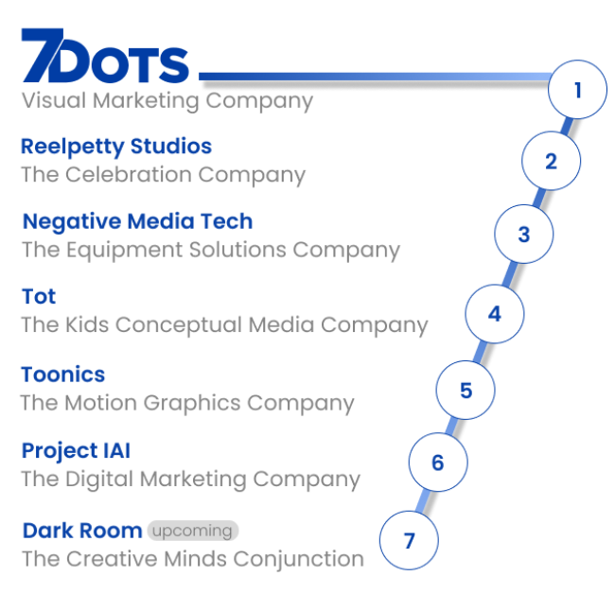

**Figure 1.1 – Company Structure**

**1.2. PROBLEM DEFINITION**

The current approach to lead acquisition from social media platforms lacks efficiency and effectiveness. The absence of a structured data-driven engagement strategy results in a low conversion rate. To optimize the process by leveraging data-driven engagement strategies, including content creation and creative design, to attract and acquire high-quality leads.

***1.2.1. OBJECTIVE***

To streamline the lead generation process from ad campaigns on social media platforms and achieve automation in lead management. By implementing data-driven strategies and leveraging advanced analytics tools, the project aims to identify and capture high-quality leads efficiently. The automation process will involve setting up an integrated system that can track, categorize, and score leads based on predefined criteria, ensuring that only the most promising leads are shared with the sales team.

This streamlined approach will not only increase the speed of lead qualification but also improve the overall lead-to-customer conversion rate. The project's ultimate goal is to optimize resource utilization, enhance sales team productivity, and foster better alignment between marketing and sales, resulting in improved business growth and revenue generation.

The objectives of the project are

* To develop a systematic and data-driven approach for acquiring potential leads.
* To segment the target audience.
* To optimize social media campaigns.
* To reduce manual effort and increase efficiency they implement automation tools and techniques.
* To Track the workflow of tele-callers.
* To develop the lead nurturing and conversion.
* To Collaborate with the sales team for smooth transition of acquired leads for further engagement.

***1.2.2. SCOPE***

Data-driven engagement has immense potential for optimizing social media strategies. This information allows them to create highly targeted and personalized content that resonates with their followers, leading to increased engagement and brand loyalty. Moreover, data-driven analysis helps identify the most effective posting times and content types, ensuring maximum visibility and reach. Monitoring social media metrics and performance in real-time enables swift adjustments to optimize campaigns continually. Additionally, it enables businesses to identify trends, uncover customer sentiments, and respond proactively to feedback, fostering stronger customer relationships.

This project's major goal is to invoke quality leads from the social media ads and convert the leads to the sales team and automate the system.

* Marketing strategy development
* Online channel implementation
* Lead generation and conversion optimization
* Performance tracking and analysis

**1.3. OVERVIEW OF ANALYSIS**

A comprehensive analysis that covers social media analytics, automation implementation, CRM integration, Meta Ads campaign evaluation, and lead quality assessment is fundamental to the success of obtaining leads from ad campaigns on social media and achieving seamless lead sharing with the sales team.

***1.3.1. SOCIAL MEDIA***

Social media analytics is a crucial aspect of this project, as it involves collecting and analyzing data from various social media platforms to understand the campaign's performance and user engagement. The analysis should cover key metrics such as click-through rates (CTR), conversion rates, reach, impressions, engagement rates, and demographic insights. By monitoring these metrics, the project team can identify which social media channels and ad formats are most effective in generating leads and driving engagement.

The social media involves in invoke of lead:

* Facebook
* Instagram
* WhatsApp

The Analytic:

* Metri cool
* Social media

***1.3.2. ADS PERFORMANCE***

Meta ads campaigns refer to the use of metadata and ad targeting techniques to reach specific audience segments. The analysis should encompass the effectiveness of different Meta ads strategies, such as keyword targeting, audience targeting, and interest-based targeting. By tracking the performance of each Meta ad campaign, the project team can optimize ad spend, refine targeting parameters, and enhance the overall return on investment (ROI) from the ad campaigns.

The analytics of meta are interpreted.

***1.3.3. AUTOMATION***

The automation aspect of the project plays a pivotal role in streamlining the lead generation and management process. Automation tools should be employed to capture lead information automatically, such as contact details, preferences, and behavior data. Furthermore, automation can be used to segment and categorize leads based on predefined criteria, enabling efficient lead scoring. Automated lead nurturing processes can also be implemented to engage and qualify leads through personalized content and targeted follow-ups.

The Analytic:

* Wati
* Interakt
* Zapier

***1.3.4. CRM***

Integrating the lead generation system with a CRM platform is essential for effective lead management. The analysis should focus on selecting and configuring a CRM system that aligns with the organization's needs and allows seamless data transfer between the lead generation platform and the sales team's CRM. This integration enables a centralized view of leads and prospects, ensuring the sales team has real-time access to lead information, enabling them to prioritize and follow up with the most promising leads promptly.

The Analytic:

* Zoho crm

These are the few platforms that are to be skilled for better performance in the data driven process.

***1.3.4. TOOLS***

* Canva
* Web flow
* Word press
* Photoshop
* After-effects
* Figma
* Wati
* Interakt
* Meta business Suite
* Zapier
* Zoho crm
* Metricool
* Final Cut Pro

***1.3.5. WORKFLOW FUNNEL***

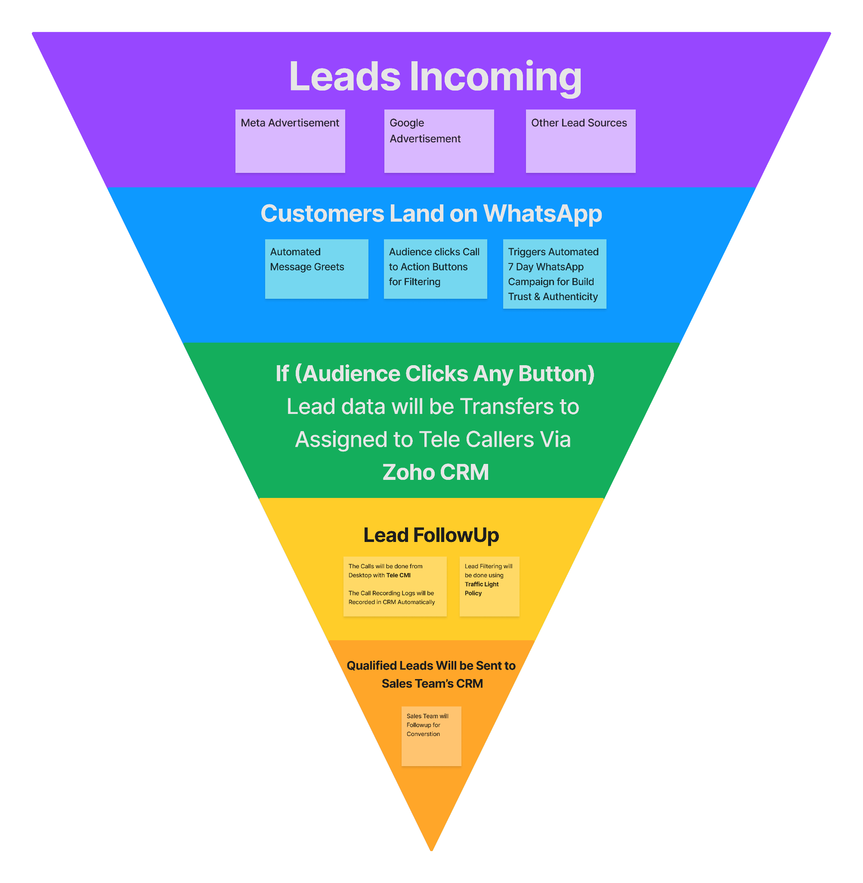

**Figure 1.2 – Workflow Image**

**1.4 INFERENCES SUMMARY**

* Leveraging social media analytics for lead generation can optimize ad campaign performance and resource allocation, driving better audience engagement and conversion.
* Analyzing Meta ads campaigns provides valuable insights into ad targeting strategies, enabling optimization for reaching specific audience segments and increasing ad campaign effectiveness.
* Social media responses have improved. Because of numerous interaction tactics used on social media, the number of followers has grown over time across all social media platforms.
* Implementing automation tools streamlines lead capture and nurturing, enhancing efficiency, and personalized interactions, ultimately improving lead conversion rates.
* Integrating with CRM centralizes lead data, providing real-time access to the sales team, fostering collaboration, and prioritized follow-ups with high-quality leads, leading to increased sales success.

**CHAPTER II**

**ANALYSIS PROCESS**

This chapter gives a detailed description about the data set and the analysis process involved.

**2.1 STATISTICS ON USAGE OF AUTOMATION**

**2.1.1 *ANALYZING THE EVOLUTION AND ADOPTION RATES***Automation's burgeoning relevance is undisputed. A meticulous assessment of usage statistics indicates that there is an industry-wide gravitation towards automation tools, reflecting a commitment to streamline operations and elevate customer engagements. Within the ambit of our project, platforms like Zapier are instrumental in synthesizing functions across different utilities, crafting a synchronized customer journey. For Citroen, this not only refines operational efficiency but also plays a pivotal role in reinforcing the brand-customer interface, underpinning the entire car booking mechanism.  
  
**2. GLOBAL Automation Marketing STATISTICS**

**2.2.*UNDERSTANDING THE GLOBAL SHIFT AND IMPLICATIONS***Stepping back to take a global view, the crescendo of automation in marketing is both loud and clear. Statistically, a significant fraction of enterprises, regardless of scale, are now leveraging automated marketing tools. Platforms like Google Ads and Meta Ads, once static, are now imbued with dynamic automated features, bringing Citroen's outreach to potential clients in a real-time, context-sensitive manner. This not only sharpens brand precision but also promises a richer ROI, situating Citroen firmly on the global map.

**3. NEED FOR Automation**

**2.3*UNPACKING THE IMPERATIVES AND OUTCOMES***In the context of the automobile industry, the call for automation is both urgent and resonant. Modern consumers are characterized by their demand for speed, personalization, and fluid brand interactions. Automation addresses these demands head-on. Integrative tools like WATI and TeleCMI serve as exemplars, enabling Citroen to interface with its audience without lag, forging stronger ties and enhancing potential car bookings. In essence, automation is less a choice and more a mandate, driving forward the brand's vision and objectives.  
  
**4. Significance of a Robust CRM System in Branding**

**2.4 *Decoding CRM's Role in Customer Engagement***  
Beyond the veneer of data collection lies the profound depth of CRM (Customer Relationship Management). Zoho CRM, as integrated into our project, offers a multi-dimensional view into customer psyche, behavior, and trajectory. For Citroen, this translates into actionable insights, enabling them to tailor-make their strategies, ensuring their interventions are timely, relevant, and conversion-centric. Coupled with automation, a powerful CRM is the bedrock on which sustained brand loyalty and heightened car bookings are built.  
  
**5. The Synthesis of Platforms for a Comprehensive Strategy**

**2.5 *ASSESSING MULTI-PLATFORM INTEGRATION FOR MAXIMUM IMPACT***The linchpin of the "Data Driven Engagement" project lies in its integrative vision, weaving together the strengths of diverse platforms like Meta Ads, Google Ads, Metricool, and Microsoft Clarity. By ensuring Citroen's presence resonates across a multitude of digital touchpoints, this project crafts a multi-layered, data-informed strategy. The result? A brand that not only exists but thrives, ensuring its engagement strategies are always attuned to potential customers, thereby driving brand recall and car bookings.  
  
As the paradigm of automobile marketing continues to evolve, brands like Citroen stand at the crossroads of innovation and tradition. By infusing its strategies with robust automation and CRM tools, Citroen is not just preparing for the future but shaping it. The analytical depth of the "Data Driven Engagement" project underscores this commitment, promising a brand experience that is both enriched and expansive.

***2.3 ANALYSIS OF PLATFORMS AND TOOLS***

In today's digital era, leveraging the right set of online tools is paramount to achieve brand recognition and drive sales. In the context of the Citroen brand, a meticulous analysis of several digital platforms has been undertaken to understand their efficacy in branding and increasing bookings.  
  
**1. Meta Suite & Meta Ads**  
**Purpose:** Primarily used for targeted advertising, capturing a wide audience segment, and gathering insights on user behaviors.  
**Analysis:** Given Citroen's wide-ranging appeal, using Meta's comprehensive suite can offer advanced audience targeting. Ads here can be crafted to highlight Citroen's distinctive features, directly influencing bookings.  
  
**2. Google Ads**  
**Purpose:** For search and display advertisements across Google networks.  
**Analysis:** When potential customers search for terms related to cars or specifically for Citroen, Google Ads ensures top-of-the-line visibility. Its data-driven insights can refine keyword targeting, effectively boosting bookings.

**3. WATI**  
**Purpose:** A tool for streamlined customer communication via WhatsApp.  
**Analysis:** Given the ubiquity of WhatsApp, WATI can be instrumental in directly answering queries about Citroen models, leading to an uptick in bookings through instant communication.

**4. Zapier**  
**Purpose:** Automation of workflows by connecting various apps.  
**Analysis:** By integrating apps like Zoho CRM and Metricool, Zapier can automate the lead-to-sales process, ensuring potential Citroen customers are promptly catered to, enhancing booking rates.

**5. Metricool**  
**Purpose:** Analysis, management, and measurement of digital content.  
**Analysis:** For Citroen's brand campaigns, Metricool can provide detailed analytics on content performance. By refining strategies based on these insights, branding efforts become more potent, leading to increased bookings.  
  
**6. Zoho CRM**  
**Purpose:** Customer Relationship Management, tracking leads, sales, and engagements.  
**Analysis:** A robust CRM like Zoho can streamline Citroen's customer journey. From initial inquiry to final booking, Zoho CRM ensures potential buyers experience a smooth, data-informed process.  
  
**7. Microsoft Clarity**  
**Purpose:** User behavior analytics tool.  
**Analysis:** Microsoft Clarity's heatmaps and session recordings can offer Citroen insights into how customers interact with their digital platforms. Tweaking the user experience based on this can significantly impact bookings.  
  
**8. TeleCMI**  
**Purpose:** Cloud-based communication solution for businesses.  
**Analysis:** By offering features like IVR and cloud call tracking, TeleCMI can efficiently handle customer queries about Citroen, leading to improved customer satisfaction and potentially higher bookings.  
  
Leveraging these digital tools, when done methodically, can result in a substantial uptick in Citroen's brand recognition and booking numbers. Regular evaluations and iterative strategies, based on data-driven insights from these tools, ensure Citroen remains a dominant player in the automobile market.

**CHAPTER III**

**STUDY PROCESS**

This chapter gives a detailed description about various models and techniques used, a comparison of those techniques and the proposed technique.

**3.1. DIGITAL MARKETING STRATEGY**

Following are the existing system prevailing in the organization for Digital Marketing practice :

***3.1.1. SOCIAL MEDIA MARKETING (SMM)***

Social Media Marketing (SMM) plays a crucial role in promoting the Quality leads solution in this project. SMM involves leveraging popular social media platforms like Facebook, Instagram, Twitter, and LinkedIn to engage with the target audience. The steps involved in this project's SMM strategy include:

* Creating a social media content plan
* Developing compelling and relevant content
* Implementing social media advertising campaigns
* Engaging with the audience through comments, messages, and interactions
* Monitoring and analyzing social media metrics
* Adjusting the strategy based on data-driven insights
* Through SMM, the project aims to increase brand awareness, drive website traffic, and generate leads by effectively utilizing the power of social media platforms.

***3.1.2. CONTENT MARKETING***

For this project, the content marketing strategy focuses on promoting the Quality leads solution and engaging with the target audience. The steps involved in content marketing for this project are as follows:

1. **Define Target Audience:** Identify the specific target audience for the Quality leads solution. Understand their demographics, interests, and pain points related to energy efficiency, sustainability, and roof maintenance.
2. **Set Goals and Objectives:** Define clear goals and objectives for the content marketing campaign. These may include increasing awareness about the benefits of cool roof paint, driving website traffic, generating leads, and positioning the organization as an industry leader.
3. **Content Strategy and Planning:** Develop a content strategy that aligns with the target audience and project objectives. Determine the types of content that resonate with the audience, such as articles, videos, case studies, infographics, or customer testimonials. Plan the content calendar and outline topics to address the audience's pain points and provide valuable insights.
4. **Content Creation:** Produce high-quality and informative content that highlights the advantages of cool roof paint. Create content that educates the audience about energy efficiency, cost savings, environmental benefits, and the durability of the product. Use visuals, data, and real-life examples to make the content engaging and persuasive.
5. **Content Optimization:** Optimize the content for relevant keywords related to cool roof paint, energy efficiency, and roof maintenance. Ensure the content is well-structured, easily scannable, and optimized for search engines. Incorporate internal and external links to relevant resources to provide additional value to the audience.
6. **Content Distribution:** Promote the content across various channels to reach the target audience. Share the content on the company website, blog, and social media platforms. Leverage email newsletters, industry forums, and partnerships with influencers or industry experts to expand the reach of the content.
7. **Engagement and Interaction:** Encourage audience engagement by enabling comments, social sharing, and feedback mechanisms. Respond to comments and questions promptly to foster a sense of community and build trust. Encourage user-generated content, such as customer testimonials or success stories, to enhance credibility and engage the audience.
8. **Performance Measurement and Analysis:** Monitor the performance of the content marketing efforts using analytics tools. Track website traffic, engagement metrics, conversion rates, and social media interactions. Analyze the data to assess the effectiveness of the content, identify areas for improvement, and make data-driven decisions to optimize the content marketing strategy.

***3.1.3. ADS MANAGER(CAMPAIGN)***

To gain lead generation begins with a comprehensive understanding of the target audience. Conducting thorough market research helps identify key demographics, interests, and pain points, enabling the creation of highly targeted and compelling ad campaigns. Leveraging various ad formats such as lead generation ads, carousel ads, and video ads can capture users' attention and encourage them to take action.

Additionally, optimizing landing pages and forms for a seamless user experience is crucial. A/B testing different ad creatives, targeting options, and landing page elements allows continuous improvement based on real-time data insights. Regularly monitoring campaign performance metrics like click-through rates, conversion rates, and cost per lead helps refine the strategy and ensures maximum ROI. By continuously analyzing and optimizing the ad campaigns, Ads Manager can achieve consistent lead generation success and drive business growth.

***3.1.4. AUTOMATION***

A digital marketing strategy for automation aims to leverage advanced technology to streamline and optimize marketing processes. It involves implementing automated tools and systems for lead capture, email marketing, social media scheduling, and personalized content delivery. By automating repetitive tasks, such as email campaigns and social media posts, the strategy enables marketers to focus on strategic planning and creative initiatives. Furthermore, automation allows for data-driven decision-making, as it tracks and analyzes user behavior and engagement, providing valuable insights to refine marketing efforts and deliver targeted, relevant content to the right audience at the right time, ultimately enhancing overall efficiency, effectiveness, and ROI.

***3.1.5. CRM***

CRM automation aims to streamline lead generation and customer relationship management processes. By integrating a CRM system with digital marketing tools, the strategy enables automatic capture and organization of lead data, facilitating prompt and personalized lead nurturing. Through automated email campaigns, targeted content delivery, and dynamic lead scoring, the CRM system efficiently identifies and prioritizes high-quality leads for the sales team. Moreover, the strategy leverages CRM insights to track customer interactions, preferences, and behavior, enabling businesses to tailor their marketing efforts for better engagement and increased customer retention. With CRM automation, the digital marketing strategy optimizes efficiency, enhances customer experiences, and empowers businesses to build lasting and profitable relationships with their audience.

**3.2. DIGITAL MARKETING PLAN**

***3.2.1. PROPOSED SYSTEM***

The proposed system for Clients marketing aims to enhance the organization's digital marketing efforts and drive effective promotion of the product. It involves the implementation of various strategies and tools to optimize leads, automation, crm and conversions.

The proposed system includes the integration of advanced analytics, targeted advertising campaigns, content marketing, social media engagement, ads manager, automation, CRM. It also incorporates the development of a comprehensive marketing dashboard to track key metrics and provide actionable insights. The proposed system emphasizes a data-driven approach, allowing the organization to make informed decisions, refine marketing strategies, and maximize the impact of booking for the test drive for the sales team. Overall, the proposed system aims to enhance the organization's online presence, attract the target audience, and achieve marketing objectives effectively.

* **Target Audience Analysis:**

1. Conduct thorough market research and analysis to identify the target audience for cool roof paint.
2. Define buyer personas based on demographics, preferences, and pain points.
3. Understand the target audience's online behavior, including their preferred digital platforms and content consumption habits.

* **Social Media Marketing (SMM):**

1. Leverage social media platforms such as Facebook, Instagram, Twitter, and LinkedIn to reach the target audience.
2. Create engaging and shareable content related to cool roof paint.
3. Run targeted social media ad campaigns to increase brand awareness and drive website traffic.

* **Content Marketing:**

1. Develop a content marketing strategy that includes blog posts, infographics, videos, and downloadable resources.
2. Create informative and valuable content that educates the audience about the benefits of cool roof paint.
3. Promote content through social media, email marketing, and influencer collaborations.

* **Automation:**

1. Create an automated customer journey that guides prospects through the sales funnel and converts them into customers.
2. By leveraging customer data and behavior, businesses can automate personalized email campaigns, targeted advertisements, and tailored content, resulting in higher engagement and customer satisfaction
3. This consistency helps maintain the quality of customer interactions.

* **CRM:**

1. By analyzing customer data and trends stored in the CRM system, marketers can identify patterns, preferences, and opportunities for improvement.
2. CRM tools can integrate with marketing automation platforms, enabling marketers to automate repetitive tasks and workflows
3. Allow businesses to respond to inquiries promptly, send personalized content, and track lead interaction.

* **Performance Tracking and Analytics:**

1. Implement robust analytics tools to track the performance of marketing campaigns.
2. Monitor key metrics such as leads, conversions, engagement, and ROI.
3. Regularly analyze data to identify areas for improvement and make data-driven decisions.

**3.3. SOCIAL MEDIA PLATFORMS AND ANALYSIS TOOLS**

For the specific project of promoting cool roof paint, the following social media platforms and analysis tools can be considered:

***3.3.1. FACEBOOK***

Utilizing Facebook as a primary social media platform to reach a wide audience and run targeted advertising campaigns. Leveraging Facebook Insights for performance metrics and audience insights.

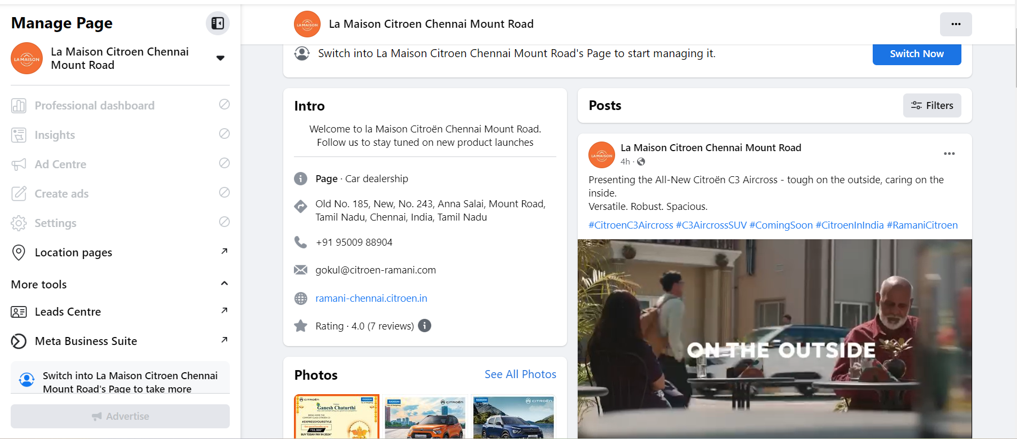

**Figure 3.1 Facebook community posting**

***3.3.2. INSTAGRAM***

Leveraging Instagram's visual nature to showcase the benefits and aesthetics of cool roof paint. Use Instagram Insights to track engagement, follower growth, and demographics.

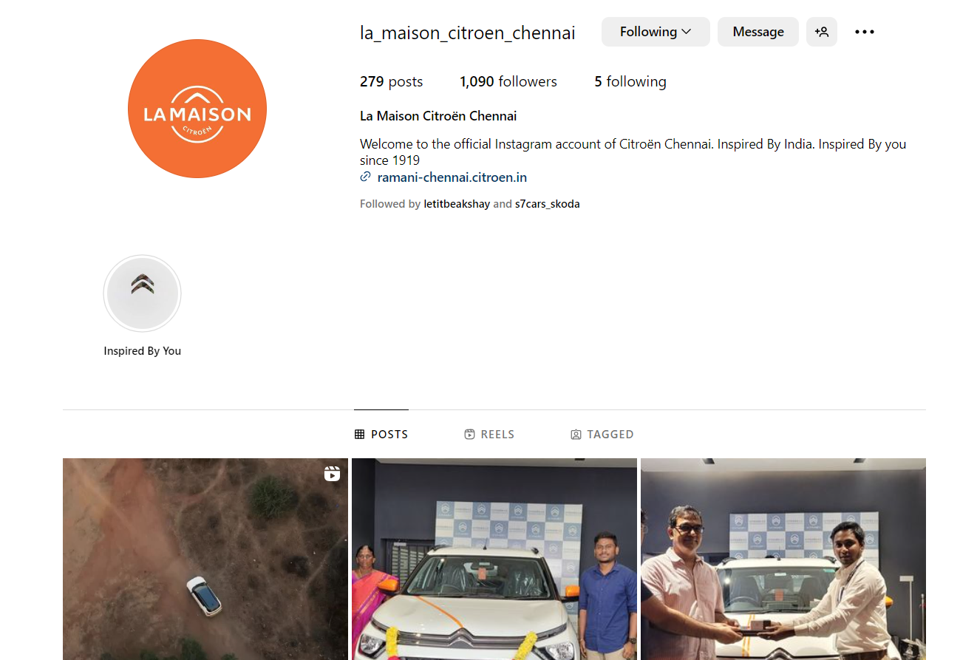

**Figure 3.2 Instagram post**

***3.3.1 METRICOOL***

By integrating with various digital platforms, including social media, websites, and email marketing, Metricool collects and consolidates data on website traffic, social media engagement, and email campaign performance. Its user-friendly dashboard provides valuable insights and reports, allowing marketers to monitor key metrics, track audience behavior, and identify trends. Through Metricool's analytics, businesses can refine their digital marketing strategies, measure the effectiveness of their campaigns, and make data-driven decisions to improve online presence, audience engagement, and overall marketing ROI. With Metricool, digital marketers gain a deeper understanding of their online performance, enabling them to implement targeted and effective marketing tactics, achieve better campaign outcomes, and ultimately enhance their digital marketing success.

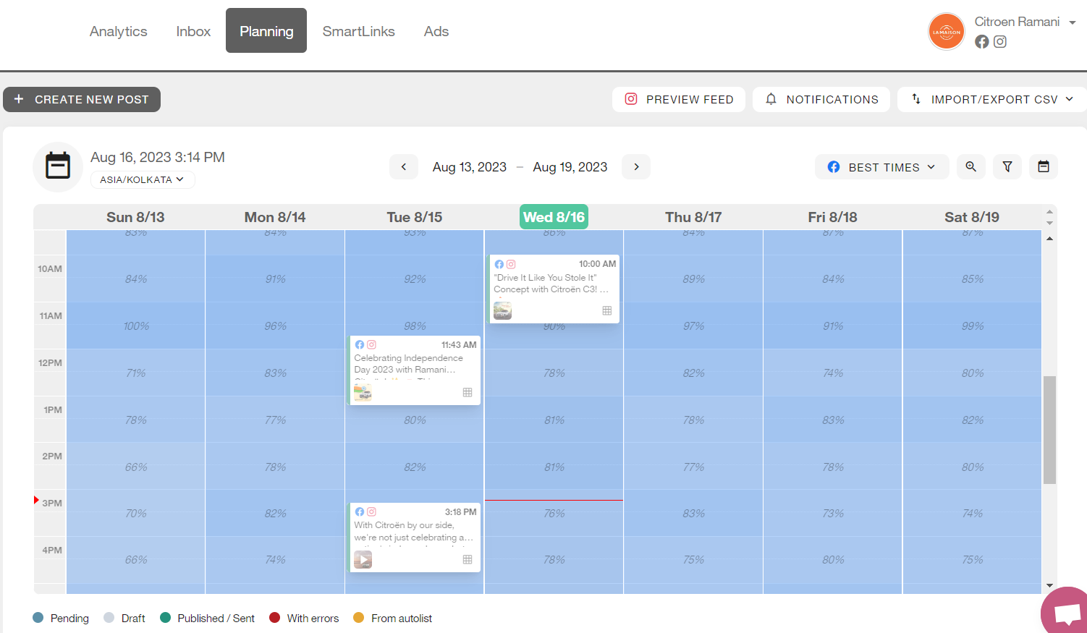  
**Figure 3.3 – Facebook Preferred Time**

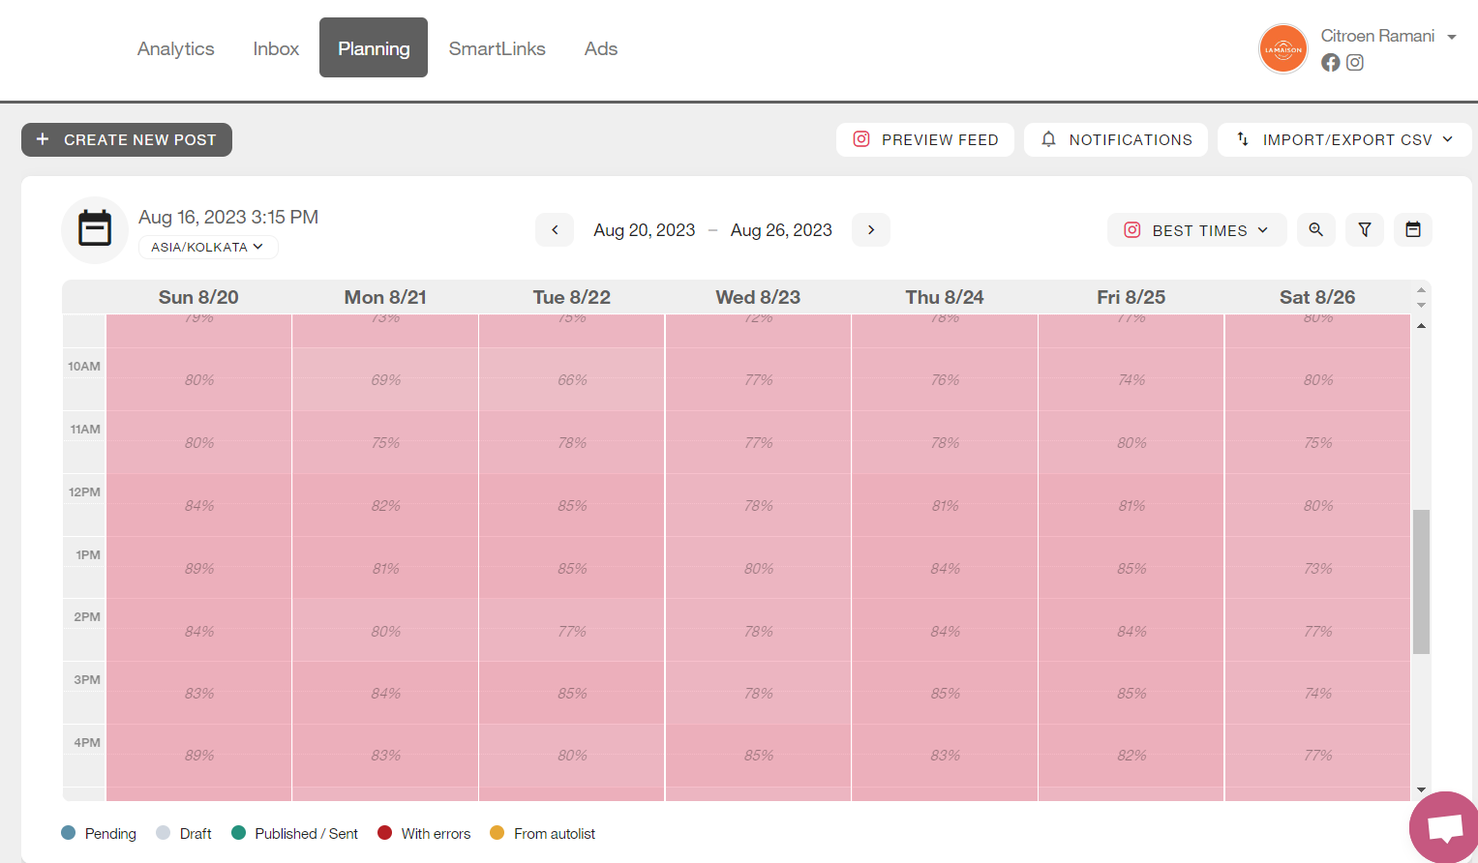  
**Figure 3.4 – Facebook Preferred Time**

***3.3.2 ADS MANAGER***

These ads allow businesses and advertisers to promote their products, services, or content to a highly targeted audience on various Meta-owned platforms, such as Facebook, Instagram, and Messenger. With the help of Meta Ads Manager, advertisers can create and customize ad campaigns, set specific objectives, define target audiences based on various demographic, behavioral, and interest-based criteria, and allocate budgets.

The platform offers a range of ad formats, including photo ads, video ads, carousel ads, and more, allowing advertisers to tailor their content to suit different marketing goals. Meta Ads provide detailed performance metrics and analytics to help advertisers track the effectiveness of their campaigns, measure reach, engagement, and conversions, and make data-driven decisions for optimizing ad strategies. This powerful advertising tool enables businesses to reach their desired audience effectively, drive brand awareness, increase website traffic, and generate leads or sales.  
  
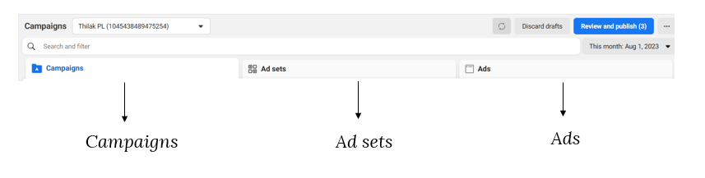  
**Figure 3.5 – Facebook Ads Structure**

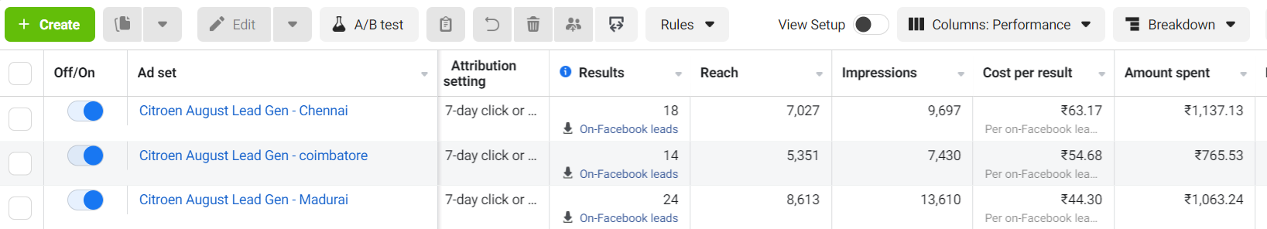 **Figure 3.6 – Facebook Ad Setup**

***3.3.3 WATI***

Wati is a cloud-based communication and automation platform that provides businesses with tools to streamline and enhance their customer engagement and communication processes. It offers features such as chatbots, voice and SMS messaging, and customer support automation. Wati enables businesses to automate routine tasks, handle customer queries, and send targeted messages to improve customer interactions. It also provides analytics and reporting capabilities to track and measure the effectiveness of communication strategies. With Wati, businesses can optimize their customer engagement, save time, and deliver personalized experiences.

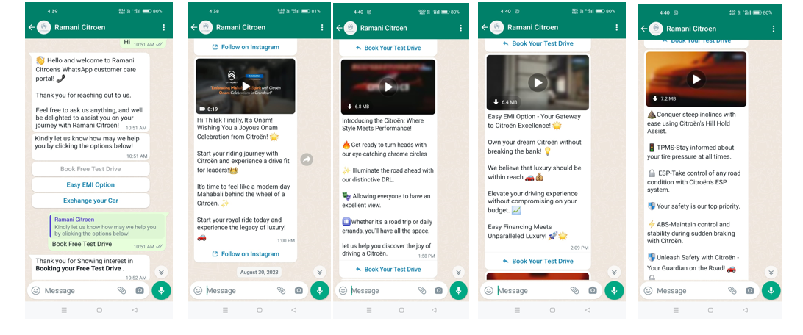  
**Figure 3.7 – WhatsApp Follow-up Message**  
  
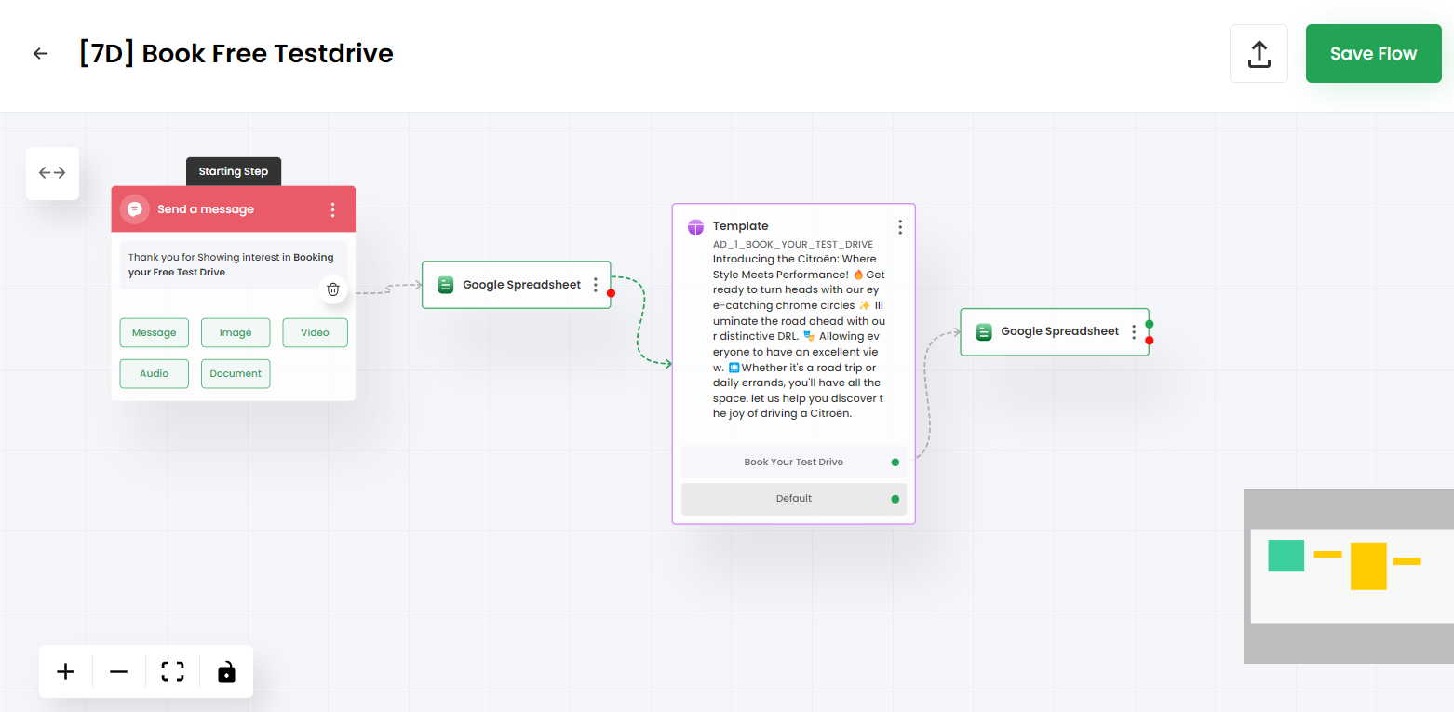  
**Figure 3.8 – WhatsApp Bot Reply Flow**

***3.3.4 ZAPIER***

Zapier is an integration platform that connects different web applications and enables them to work together seamlessly. It allows users to create automated workflows, known as "Zaps," without the need for coding or technical expertise. With Zapier, users can connect various apps and services, such as CRM systems, project management tools, email marketing platforms, and more, to automate data transfer and trigger actions between them. This eliminates the need for manual data entry and helps streamline processes across different applications. Zapier supports a wide range of popular web applications and provides users with flexibility and customization options to create tailored integrations.

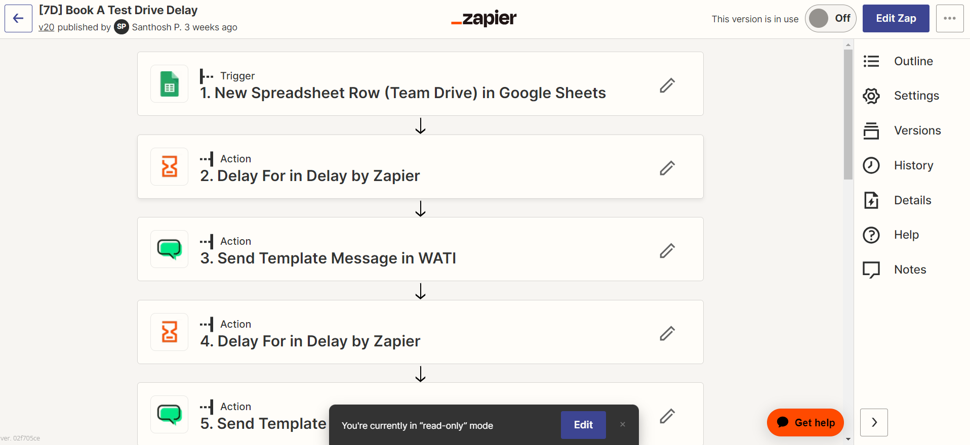

**Figure 3.9 – Automation Setup**

***3.3.5 ZOHO CRM***

Zoho CRM is a comprehensive customer relationship management platform that helps businesses manage and streamline their sales, marketing, and customer support processes. It offers a wide range of features, including lead management, contact management, deal tracking, email marketing, analytics, and reporting. Zoho CRM allows businesses to centralize customer data, track interactions, automate workflows, and collaborate effectively within teams. It also integrates with various other Zoho applications and third-party tools to provide a complete CRM solution tailored to the needs of businesses of all sizes.

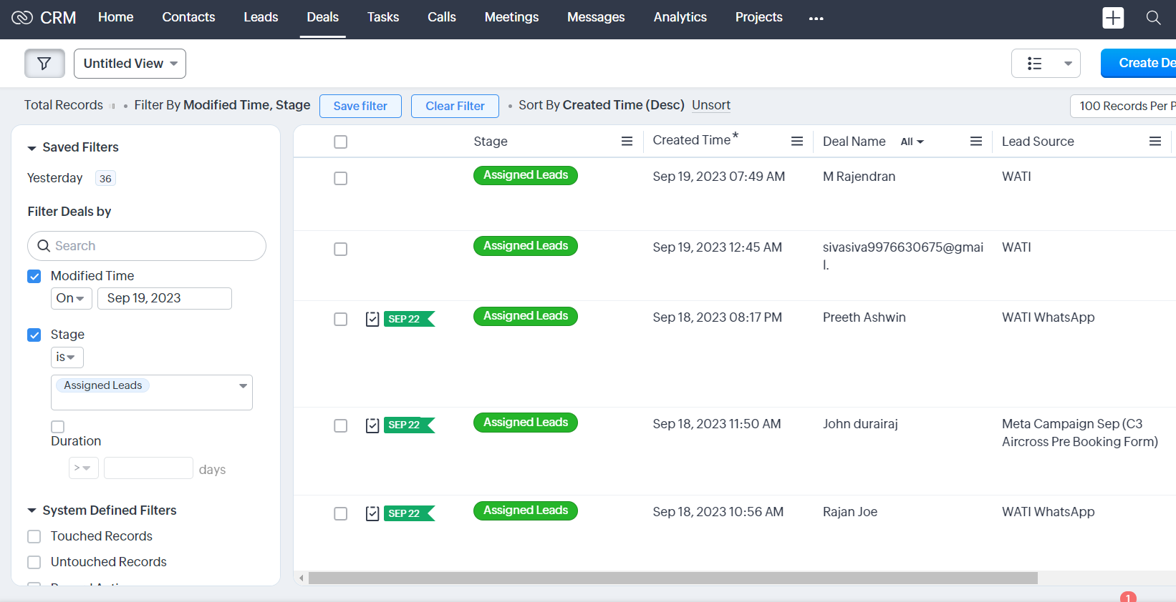  
**Figure 3.10 – Zoho CRM Setup**

***3.3.6 GOOGLE ADS***

Google Ads, a powerful online advertising platform, enables businesses to create and display targeted ads across Google's vast network, including search results, websites, and mobile apps. Through strategic keyword selection and audience targeting, Google Ads helps businesses reach their desired customers precisely when they are searching for products or services. Advertisers pay only when users engage with their ads, making it a cost-effective way to increase visibility, drive traffic, and achieve marketing goals. With extensive analytics and optimization tools, Google Ads empowers businesses to track performance, refine strategies, and maximize the impact of their online advertising campaigns  
.

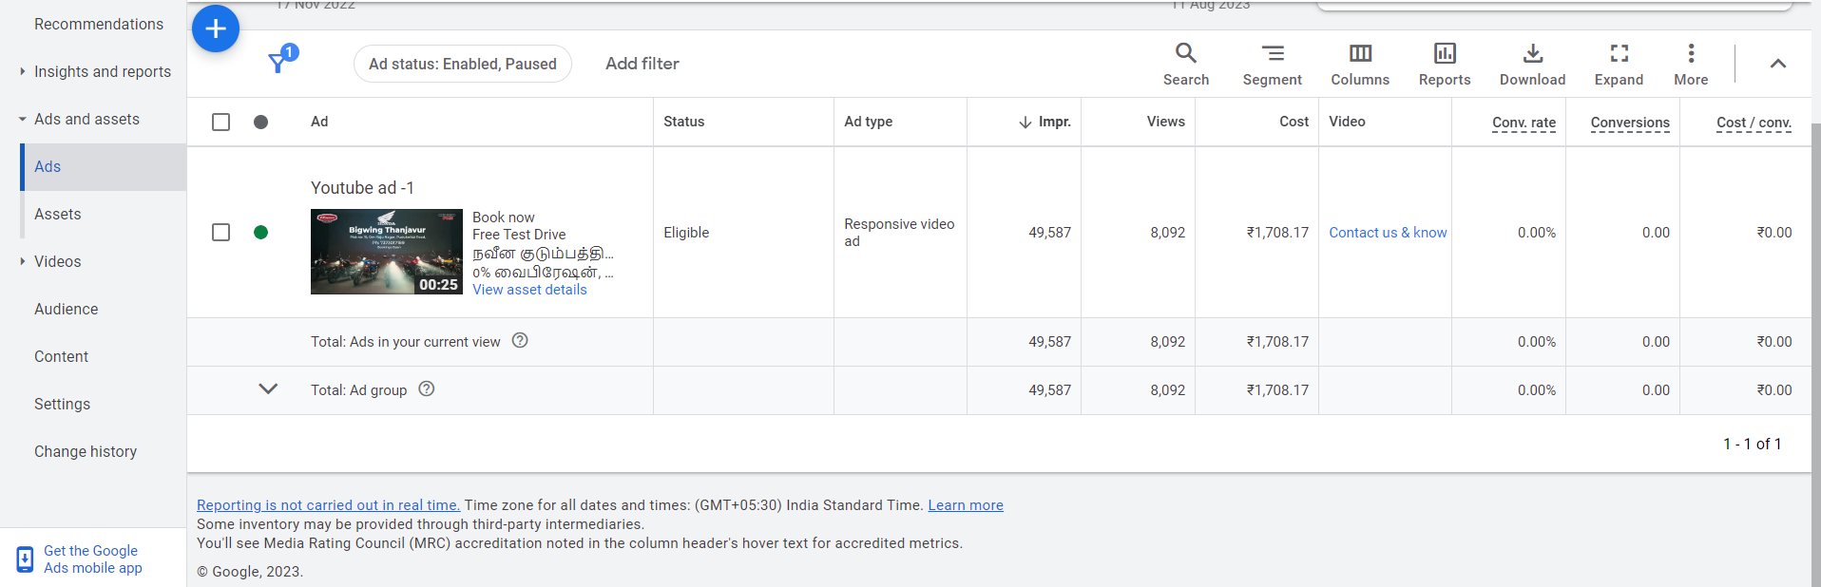  
**Figure 3.11 – Google ads Setup**

***3.3.7 TELECMI***

TeleCMI stands for Telecommunications Customer Management and Insights. It refers to the specialized field within the telecommunications industry that focuses on managing customer relationships and deriving valuable insights from customer data. TeleCMI involves strategies, technologies, and practices to enhance customer experiences, provide personalized services, and make data-driven decisions to improve service offerings. This encompasses customer service, data analysis, predictive modeling, and utilizing advanced technologies to create better communication experiences for customers in the ever-evolving telecommunications landscape.

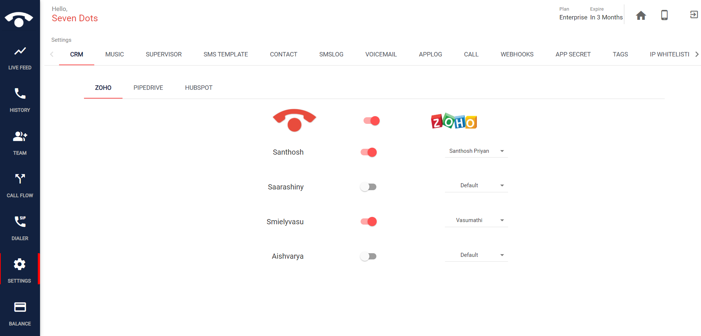  
**Figure 3.12 – Zoho CRM connection to Tele CM**

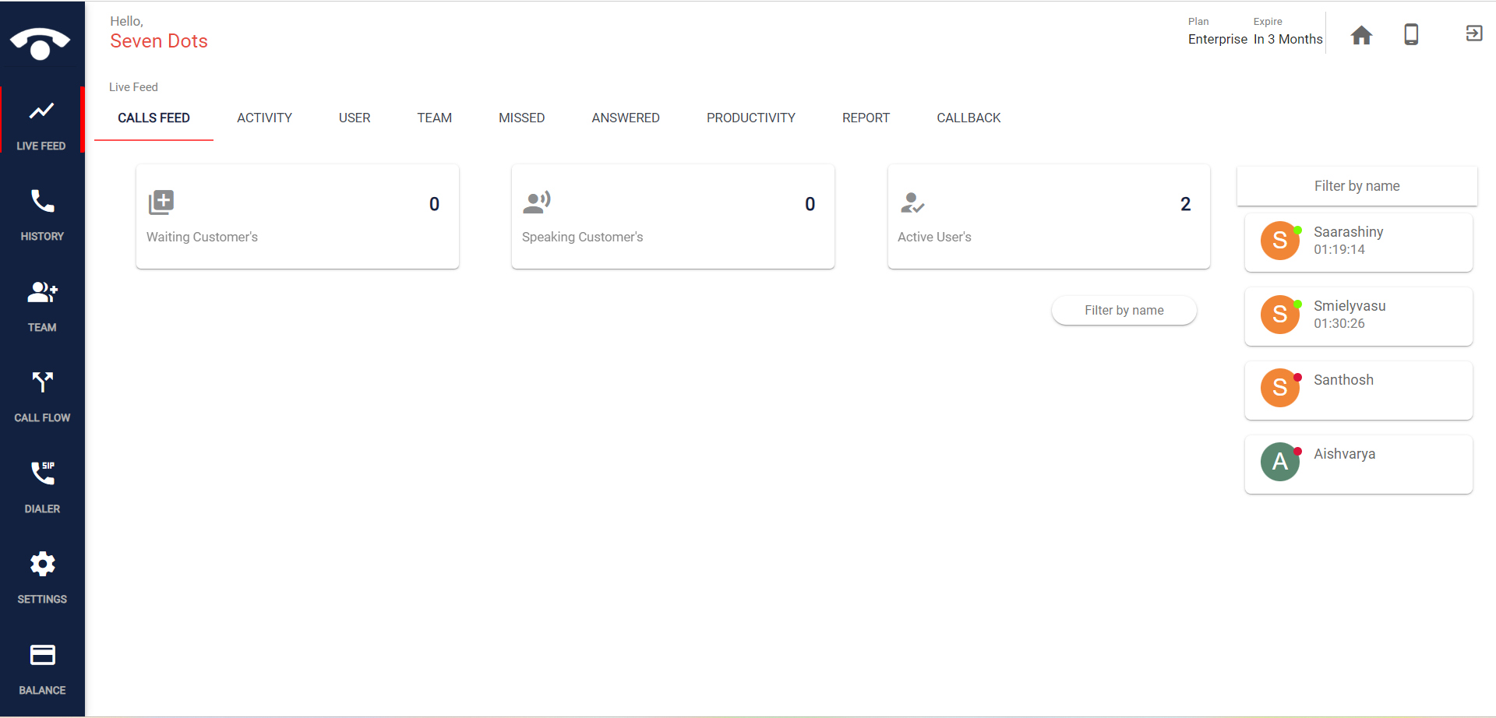  
**Figure 3.13 – Tele CM Setup**

***3.3.8 MICROSOFT CLARITY***

Microsoft Clarity is a web analytics tool provided by Microsoft that helps website owners and developers understand user behavior on their websites. It offers insights into how visitors interact with web pages, including heatmaps, session recordings, and other user tracking features. Clarity provides data on user clicks, scrolls, and mouse movements, helping website administrators identify issues, optimize user experience, and make data-driven decisions to improve website performance and user engagement.

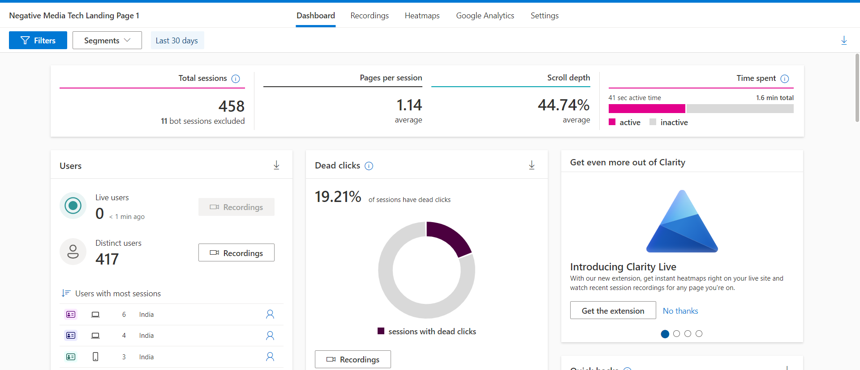

**Figure 3.14 – Microsoft Clarity Setup**

**CHAPTER IV**

**IMPLEMENTATION AND ANALYSIS**

There are ways to implement the process as per the digital marketing plan. This chapter briefs the implementation of the Digital Marketing plan and analysis.

**4.1 CUSTOMER ONBOARDING PROCESS**

* **Understanding the Business & Customer:** Technically, this stage involves conducting in-depth market research and customer analysis using data analytics tools, surveys, and social listening platforms. Data is collected to understand customer demographics, behavior, preferences, pain points, and market trends.
* **Creating a Marketing Strategy:** The creation of a marketing strategy entails leveraging data insights and analytics to develop a comprehensive plan that outlines marketing objectives, target audience segments, key messaging, and the channels to be used for promotion. Marketing automation tools and project management software may be utilized to streamline the strategy development process, allocate resources, and set measurable goals and KPIs for the marketing campaigns.

**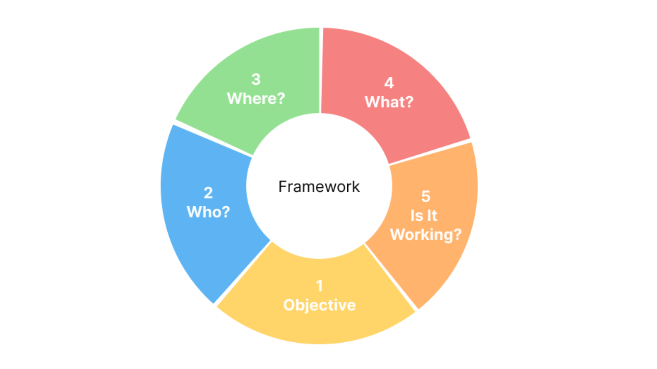  
Figure 4.1 – Framework**

1. Objective & Brief
2. Understand the Brief & Define all Objectives
3. Understand Business Vision
4. Understand the Market and Competitors
5. Owned Asset Audit
6. Who?
7. Audience Analysis
8. Audience Persona & Sizing
9. Where?
10. Deploying Strategy
11. Choosing the Optimal Channel
12. Inventory Selection
13. Investment and Expected Deliverables
14. What?
15. Messaging and Formats
16. Is It Working?
17. Right Approach to Reporting
18. Tech Recommendations & Tools
19. Data Collection, Enrichment and Activation Strategy

* **Finalizing the Contract:** Technically, finalizing the contract involves utilizing electronic signature platforms or blockchain-based contract management solutions to securely draft, negotiate, and execute contracts with clients or vendors.
* **Assigning the Team & Process:** In this stage, project management software and collaboration tools are used to assign roles and responsibilities to team members. This includes setting up task lists, timelines, and workflow processes to track progress and manage project deliverables efficiently.
* **Initial Reporting:** Technically, initial reporting involves using data analytics tools to track and measure the performance of marketing campaigns during their early stages. This includes monitoring key performance indicators (KPIs) such as website traffic, lead generation, conversion rates, and social media engagement. Real-time reporting dashboards and data visualization tools are used to present data insights for quick decision-making and optimization of marketing strategies.
* **Setting up Marketing Assets**: Setting up marketing assets involves utilizing content management systems (CMS), website builders, and design software to create and manage marketing collateral, such as websites, landing pages, email templates, and social media graphics. These assets are optimized for mobile responsiveness and search engine visibility, ensuring a seamless user experience across different devices and platforms.

**4.2 CONTENT LEVEL PROCESS**

Content level processing refers to the systematic and structured approach of managing content at various stages of its lifecycle, from ideation and creation to publishing and analysis. It involves a series of steps and actions to ensure that content is optimized, relevant, and effective in achieving its intended objectives. The content level processing can be broken down into the following key stages.

* **Profile Optimization:**Profile optimization involves enhancing and fine-tuning various aspects of a user's online profile or presence to improve visibility, relevance, and overall performance. In the context of content creation, profile optimization typically refers to optimizing social media profiles, websites, or other online platforms where content will be published.
* **Content Collection:** Content collection is the process of gathering relevant and valuable information, data, images, or multimedia elements that will be used to create content. This can involve conducting research, curating data from various sources, sourcing images or videos, and collecting user-generated content or feedback.
* **Content Creation:** Content creation is the actual process of developing and producing the content pieces based on the collected information and materials. This can encompass various formats, such as blog posts, articles, social media posts, videos, infographics, or podcasts.

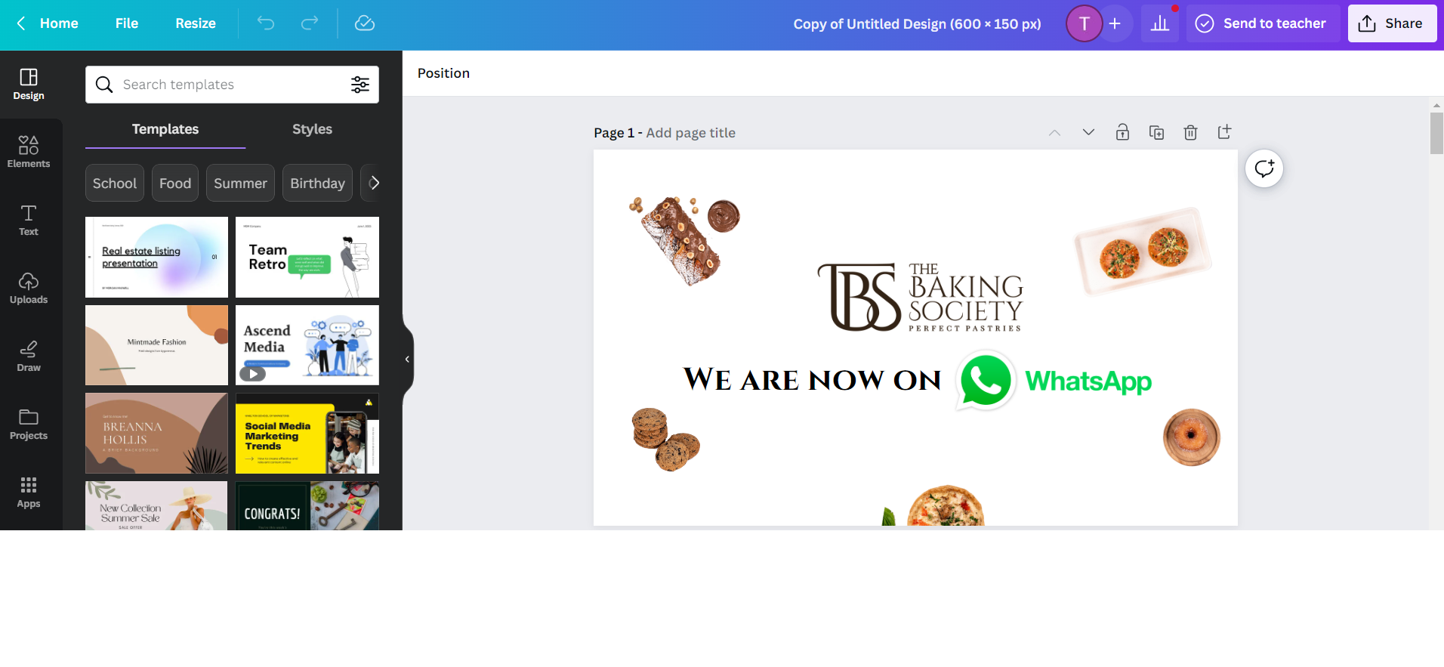  
**Figure 4.2 – Canva Work Page**

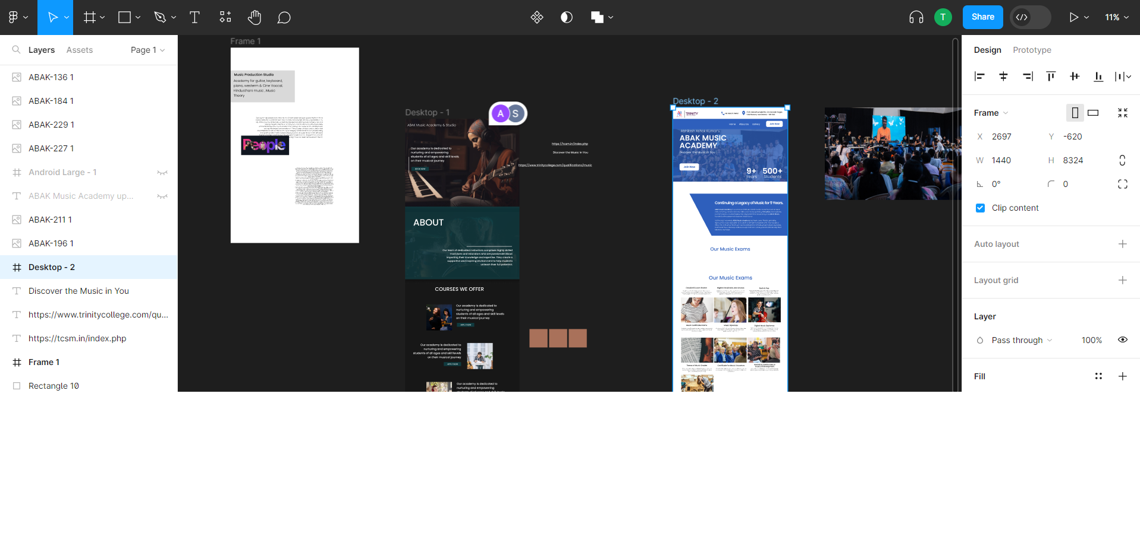  
**Figure 4.3 – Figma Work Page**

* **Content Verification:** Content verification is the critical step of ensuring the accuracy, credibility, and quality of the content before publishing. It involves fact-checking, reviewing sources, confirming data accuracy, and validating any claims or statistics presented in the content.

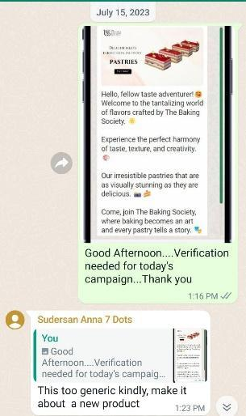  
**Figure 4.4 – Content Approval**

* **Content Publishing:** Content publishing is the final stage, where the finished content is released and made accessible to the target audience through the appropriate channels. This can include posting on websites, blogs, social media platforms, email newsletters, or other distribution channels.

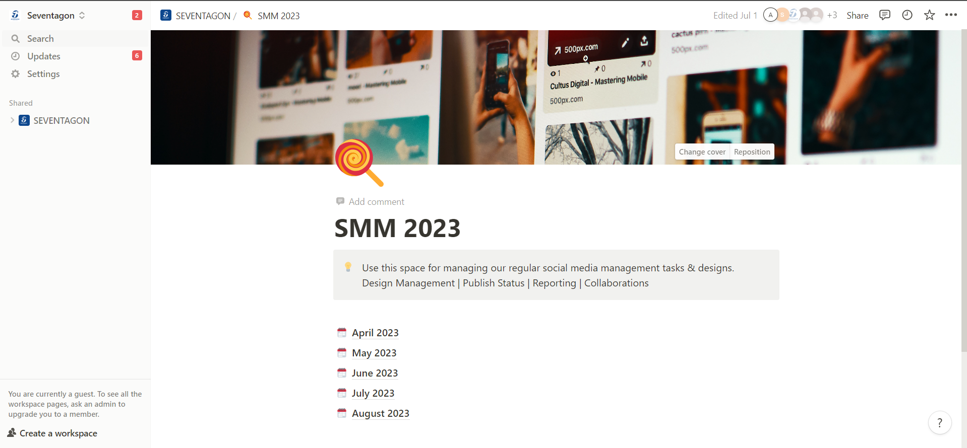

**Figure 4.5 – Content Uploading**

**4.3 HUMAN RESOURCE REQUIREMENT**

The human resources requirement involves identifying and hiring key personnel to fulfill crucial roles within the organization. These roles may include Marketing Strategist & Management, responsible for devising effective marketing plans; Customer Relationship Strategist & Management, to enhance customer satisfaction and loyalty; Content Strategist & Management, tasked with planning and executing content marketing initiatives; and Social Media Marketing Strategist & Management, responsible for driving brand awareness and engagement across social media platforms.

**Marketing Strategist & Management:** The role of a Marketing Strategist involves developing comprehensive marketing plans and strategies to achieve business objectives. They conduct market research, competitor analysis, and target audience profiling to identify opportunities and challenges. The Marketing Strategist collaborates with cross-functional teams to design and execute marketing campaigns that align with the company's goals.

**Customer Relationship Strategist & Management:** The Customer Relationship Strategist is responsible for cultivating and maintaining strong relationships with customers. They devise customer engagement strategies and design loyalty programs to enhance customer retention and satisfaction.

**Content Strategist & Management:** The Content Strategist plays a crucial role in planning and executing content marketing initiatives. They define content goals, target audience personas, and content distribution channels. The Content Strategist conducts content audits to assess existing assets and identify content gaps.

**Social Media Marketing Strategist & Management:** The Social Media Marketing Strategist oversees social media marketing efforts across platforms. They develop social media strategies aligned with brand identity and marketing goals. The Social Media Marketing Strategist creates content calendars, schedules posts, and engages with the online community to drive brand awareness and engagement.

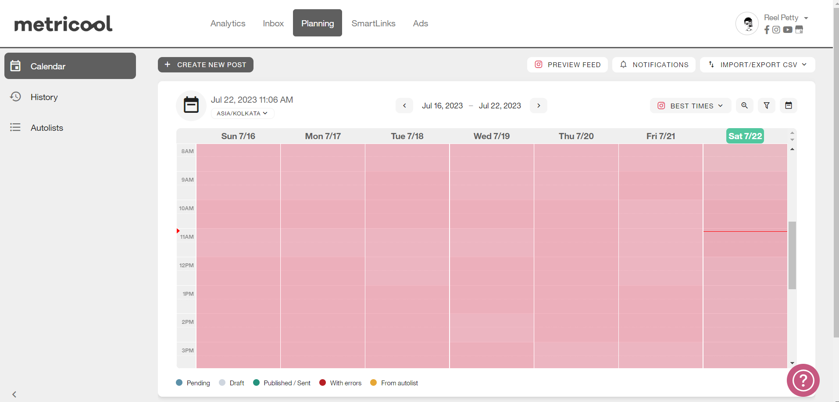  
**Figure 4.6 – Content Uploading Time on Metricool**

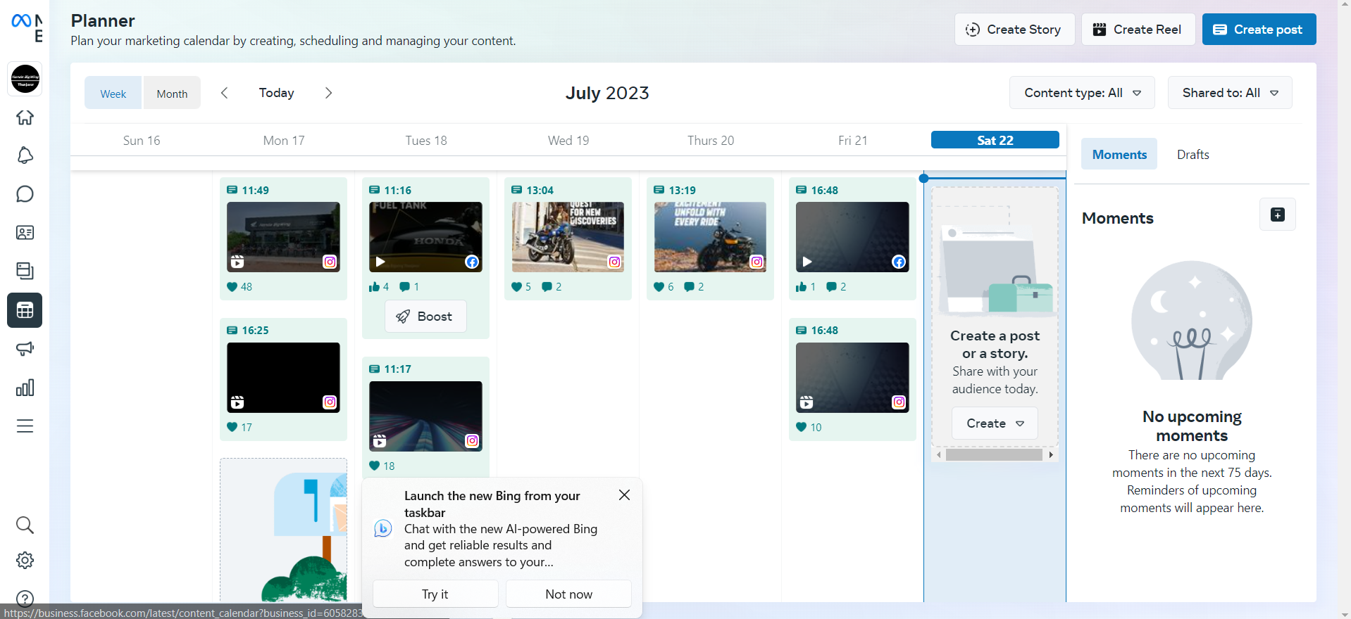

**Figure 4.7 – Content Uploading Time on Meta Suite**

**4.4 DASHBOARD DESIGN**

A quality marketing dashboard is a visual representation of key performance indicators (KPIs) and metrics related to the marketing efforts for promoting cool roof paint. It provides a centralized view of important data and insights, allowing stakeholders to track the effectiveness of marketing campaigns, make informed decisions, and optimize strategies. The steps involved in creating a quality lead marketing dashboard are as follows:

1. **Identify Key Metrics:** Determine the key metrics and KPIs that align with the marketing objectives and goals. These may include website traffic, leads generated, conversion rates, social media engagement, ad campaign performance, and customer acquisition cost.
2. **Choose a Dashboard Platform:** Select a suitable dashboard platform or tool that allows for easy data visualization and customization. Popular options include Google Data Studio, Microsoft Power BI, or Tableau.
3. **Data Collection and Integration:** Gather data from various sources, such as website analytics, social media platforms, email marketing tools, ad platforms, and CRM systems. Integrate the data into the chosen dashboard platform.
4. **Design Dashboard Layout:** Plan the layout and structure of the dashboard to ensure it is user-friendly and visually appealing. Consider the target audience and their specific needs when organizing the metrics and visual elements.
5. **Visualize Data**: Use appropriate data visualization techniques, such as charts, graphs, tables, and maps, to represent the marketing data effectively. Choose visualizations that are easy to understand and provide actionable insights.
6. **Set Up Data Connections and Refresh:** Configure the dashboard to connect to the data sources and set up regular data refresh schedules to ensure real-time or near-real-time data availability.
7. **Customize Metrics and Filters:** Customize the dashboard by adding relevant metrics and filters that allow users to drill down into specific data subsets or time periods.
8. **Test the dashboard functionality, data accuracy, and responsiveness:**Gather feedback from stakeholders and make necessary refinements to improve the dashboard's usability and effectiveness.
9. **Data Security and Access Controls:** Implement appropriate data security measures to protect sensitive information. Define access controls to ensure that only authorized users can view and interact with the dashboard.
10. **Training and Documentation:** Provide training and documentation to stakeholders on how to use the dashboard effectively. Offer guidance on interpreting the metrics, navigating the dashboard, and extracting insights for decision-making.

By following these steps, a Quality leadsmarketing dashboard can be created to provide a comprehensive and visually appealing overview of the marketing performance, enabling stakeholders to monitor progress, identify trends, and make data-driven decisions to optimize marketing strategies.

***4.4.1STRUCTURE OF THE DASHBOARD :***

| ADS MANAGER |
| --- |
|  |

| AUTOMATION |
| --- |
|  |

| CRM |
| --- |
|  |

**Figure 4.8 – Dashboard Design**

The structure of the Quality leads marketing dashboard can be organised into different sections to provide a clear and comprehensive view of key metrics and insights. Here is a suggested structure for the dashboard:

* **Overview Section:**

1. Highlights of overall performance, leads generated, and conversion rates.
2. Comparison of current performance with previous periods or benchmarks.

* **Social Media Engagement Section:**

1. Metrics for social media platforms, including followers, engagement rate, and reach.
2. Top-performing social media posts or campaigns based on engagement metrics.
3. Social media sentiment analysis or customer feedback monitoring.

* **Advertising Campaigns Section:**

1. Performance metrics for paid advertising campaigns, such as impressions, click-through rate, and cost per click.
2. Campaign-specific metrics, including ad spend, conversions, and return on ad spend (ROAS).
3. Comparison of campaign performance across different platforms or channels.

* **Content Marketing Section:**

1. Metrics related to content marketing efforts, such as blog traffic, content downloads, and engagement.
2. Top-performing content pieces based on page views, shares, or time on page.
3. Conversion metrics for content-driven lead generation or customer acquisition.

* **Lead Generation and Sales Section:**

1. Metrics related to lead generation, such as lead sources, lead quality, and conversion rates.
2. Sales metrics, including revenue generated, customer acquisition cost, and customer lifetime value.
3. Sales funnel visualization, showcasing the progression of leads through the sales pipeline.

* **Customisable Filters and Date Range:**

1. Option to filter data based on specific criteria, such as date range, campaigns, or channels.
2. Interactive elements that allow users to drill down into specific data subsets or segments.

The structure of the dashboard can be customized based on the specific needs and priorities of the quality lead marketing project. It should provide a visually appealing and user-friendly interface that allows stakeholders to quickly access and analyze the relevant marketing data and insights.

***4.4.2 Benefits of the dashboard***

The Quality leads Marketing Dashboard offers several benefits for effective monitoring and analysis of marketing efforts. Some of the key benefits include:

1. **Centralized Data Visualization:** The dashboard provides a centralized platform to visualize and analyze key marketing metrics and data related to Quality leads campaigns.
2. **Real-time Performance Tracking:** The dashboard allows real-time tracking of marketing campaigns, enabling immediate access to the latest data and insights
3. **Data-driven Decision Making:** By presenting relevant marketing data and insights in a clear and concise manner, the dashboard empowers decision-makers to make data-driven decisions.
4. **Enhanced Campaign Optimization:** The marketing dashboard facilitates campaign optimization by providing comprehensive performance metrics.
5. **Improved Efficiency and Productivity:** With all the relevant marketing data consolidated in a single dashboard, it saves time and effort spent on manual data gathering and analysis.

Overall, the quality lead Marketing Dashboard offers a centralized and visually appealing platform for tracking, analyzing, and optimizing marketing efforts.

**4.5 Analysis**

* **Performance Evaluation:** Descriptive analytics helps assess the overall performance of the meta campaign by analyzing key metrics such as impressions, clicks, conversions, and engagement rates. This analysis provides an overview of the campaign's effectiveness in achieving its objectives.
* **Audience Segmentation:** By employing descriptive analytics, marketers can segment the audience based on various attributes such as demographics, interests, and behavior. This segmentation allows for a better understanding of which audience segments are responding positively to the campaign and which require further optimization.
* **Time-Based Analysis:** Descriptive analytics allows marketers to analyze the campaign's performance over specific time periods. This helps in identifying trends, patterns, and peak engagement times, enabling marketers to schedule ads for optimal impact.
* **Geographic Analysis:** Understanding the geographic distribution of engagement and conversions is crucial in a meta campaign. Descriptive analytics helps identify regions where the campaign is performing exceptionally well or areas that may need additional attention.
* **Ad Placement Assessment:** Descriptive analytics helps evaluate the effectiveness of various ad placements and platforms within the meta campaign. Marketers can allocate budgets more efficiently based on the performance of different placements.
* **Performance Comparison:** Descriptive analytics enables marketers to compare the performance of the meta campaign across different campaigns, ad sets, and creatives. This analysis helps in identifying top-performing strategies and areas that require improvement.
* **Leads Incoming from Meta Ads, Google Ads, and Other Lead Sources:** This analytics description involves tracking and analyzing the volume and quality of leads generated from different sources, including meta ads, Google ads, and other lead channels. The analysis aims to identify which sources are most effective in driving leads, allowing marketers to optimize their ad spend and allocate resources efficiently.
* **Customer Landing on WhatsApp Automated Greets, Audience Clicking Call to Action for Filters, Triggered 7 Days WhatsApp Ads for Trust:** This analytics description focuses on monitoring user behavior within WhatsApp automated greets, specifically tracking audience interactions with call-to-action buttons for filtering preferences. Additionally, the analysis involves evaluating the effectiveness of triggered WhatsApp ads over a 7-day period to build trust and engagement with potential customers.
* **Leads Assigned to Tele-callers for Follow-up from CRM:** This analytics description pertains to monitoring the lead assignment process within the CRM system. The analysis involves tracking the lead distribution to tele-callers, ensuring fair distribution and prompt follow-up, and measuring the response time and success rate of the follow-up efforts.
* **Leads Follow-up Filtered by Traffic Light Policy, Call Analytics:** This analytics description involves analyzing the follow-up of leads based on a traffic light policy, where leads are categorized by priority. Additionally, call analytics are utilized to track call outcomes, call duration, and customer interactions during follow-up calls, providing insights into lead engagement and nurturing.
* **Qualified Leads Sent to the Sales Team - Completion of Conversion Process:** This analytics description focuses on the final stage of the lead conversion process, where qualified leads are handed over to the sales team. The analysis tracks the number of qualified leads, conversion rates, and the time taken to complete the conversion process.

**CHAPTER V**

**REPORTS AND INFERENCES**

**5.1 ANALYSIS REPORTS AND INFERENCES**

This section shows the performance of the campaigns. The results comparison and conversions.

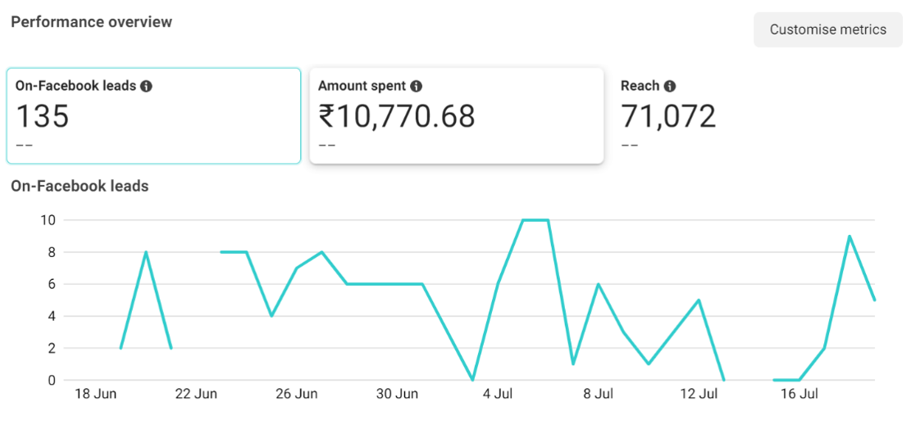  
**Figure 5.1 – Content Uploading Time on Metricool**

Figure 5.1 shows, An impressive 135 new leads were generated directly through WhatsApp. With an investment of $10,770.68, the campaign achieved a commendable reach, touching 71,072 users. This translates to a cost-per-lead of approximately $79.78, showcasing efficient utilization of budgeted funds for targeted engagement."

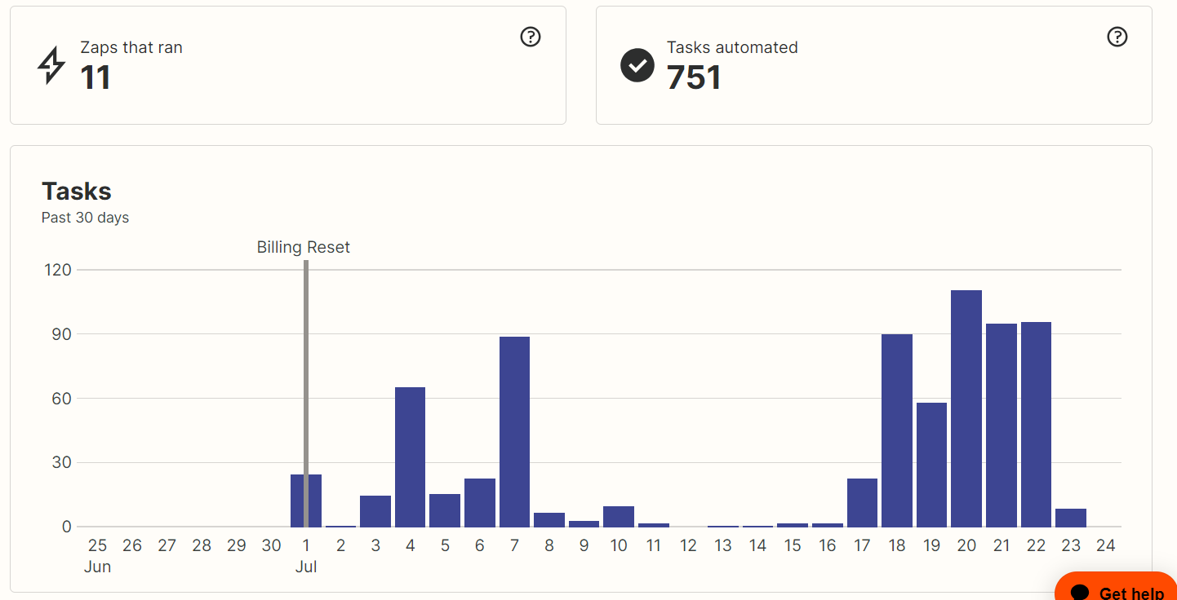  
**Figure 5.2 – Content Uploading Time on Metricool**

Figure 5.2 depicts, Zapier's integration demonstrates a robust automation synergy between Facebook, WhatsApp, and Zoho CRM, streamlining the instantaneous flow of leads records and optimizing business processes efficiently.

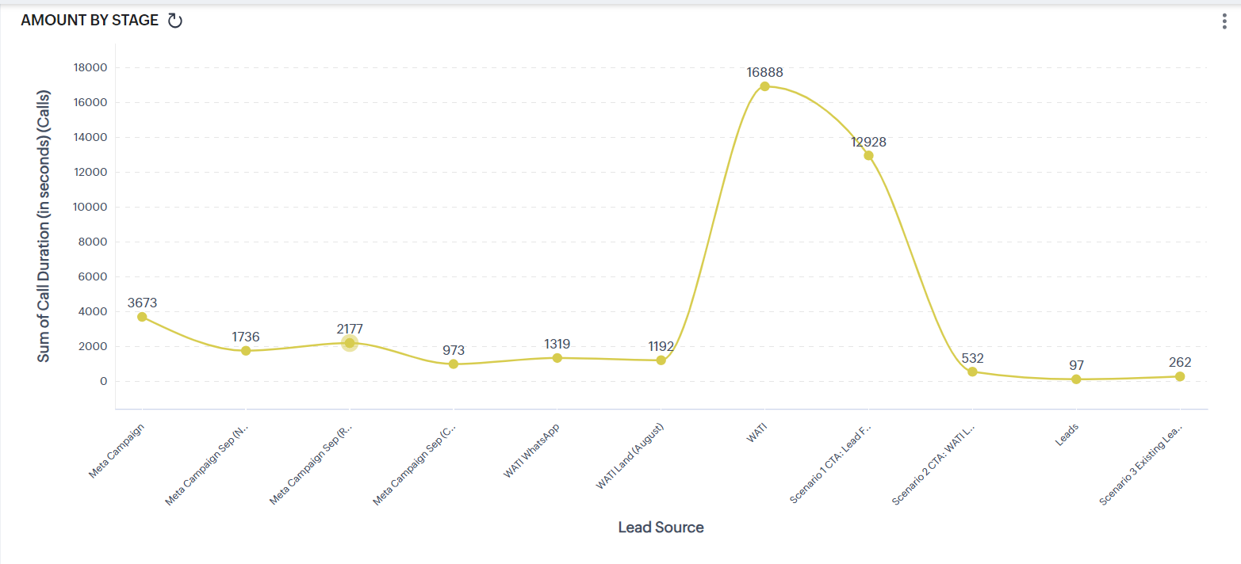  
**Figure 5.3 – Zoho Crm leads Information**

Figure 5.3 shows, Zoho CRM data reflects a higher lead conversion rate from WhatsApp sources compared to Facebook lead forms and campaigns. This underscores the growing influence and efficiency of WhatsApp as a primary channel for our target audience engagement.

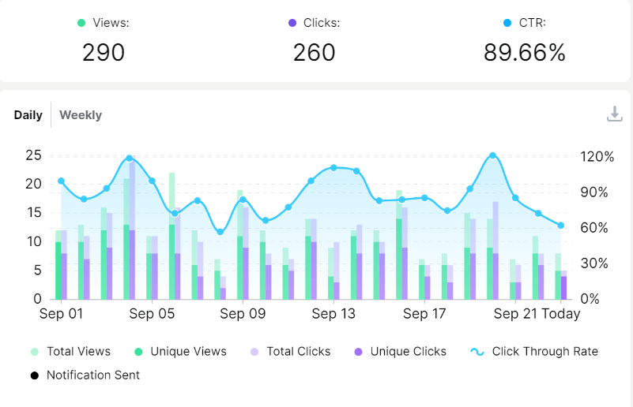

**Figure 5.4 – Landing Page Link Analytics**

Figure 5.4 describes, The Citroën landing page achieved impressive engagement with 290 views and 260 clicks, resulting in an exceptionally high click-through rate (CTR) of 89.66%, indicating highly effective link placements and relevant targeting.

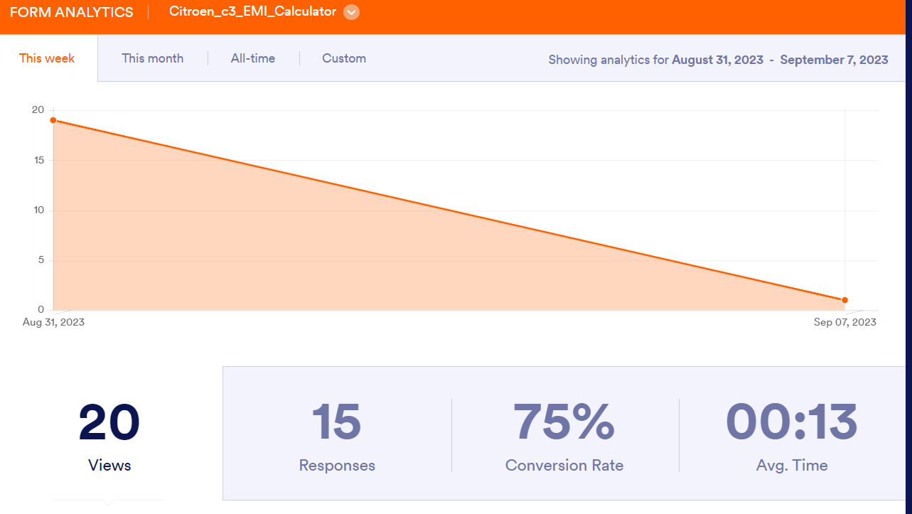  
**Figure 5.5 – Whatsapp Bot Form Analytics**

Figure 5.5 shows the analytics for the Citroën bot on WhatsApp, we observed a strong 75% conversion rate with 20 views leading to 15 responses. On average, users spent 13 seconds engaging with the bot form.

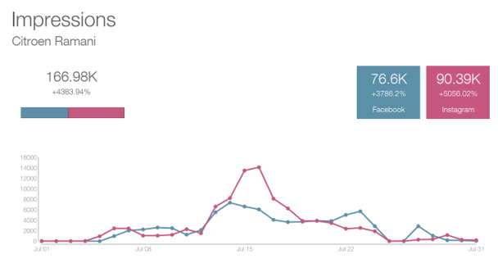  
**Figure 5.6 – Metricool Social Media Analytics**

Figure 5.6 describesCitroën's digital presence is on a significant upswing, with Facebook impressions tallying a robust 76.6k and an even stronger 90.39k impressions on their main platform, indicating a promising growth trajectory and high audience engagement.

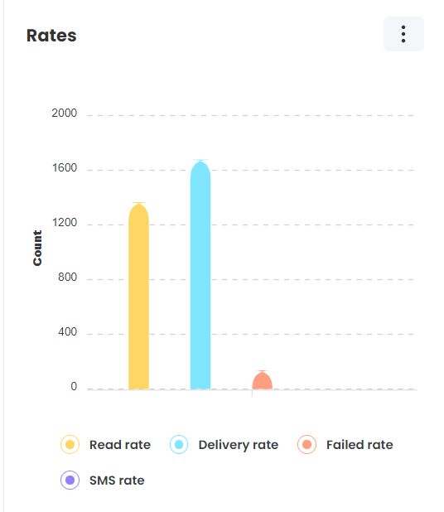  
**Figure 5.8 – Whatsapp Bot Form Analytics**

Figure 5.8 shows WATI's exceptionally low failure rate stands out, presenting Citroën with a trust-building advantage, even as its impressive delivery and read rates further solidify its brand reliability.

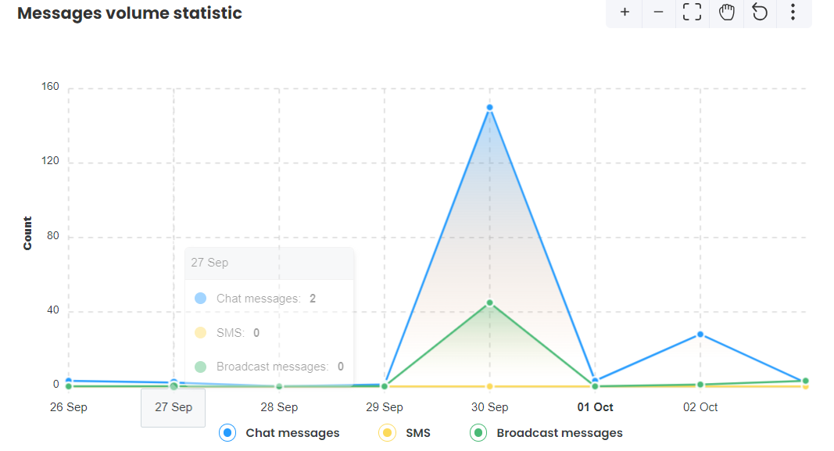  
**Figure 5.9 – Whatsapp Bot Form Analytics**

Figure 5.9 describes, the 'wait chat' responses from users notably surpassed the broadcast messages, underscoring the brand's successful strategy in deeply valuing and engaging with its customers.

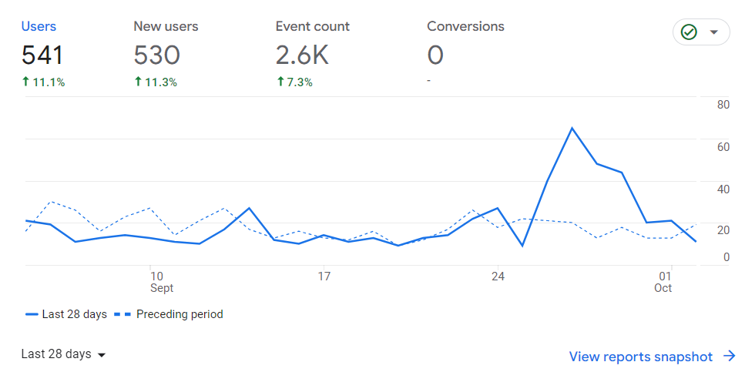  
  
**Figure 5.10 – Whatsapp Bot Form Analytics**

Figure 5.10 depicts ,Microsoft Clarity indicated a notable influx of 541 users, with 530 being new visitors. While there was a significant event count of 2.6k on the site, there were negligible direct website engagements; however, the Citroën's automation structure prompted a higher user response through WhatsApp call-to-action.

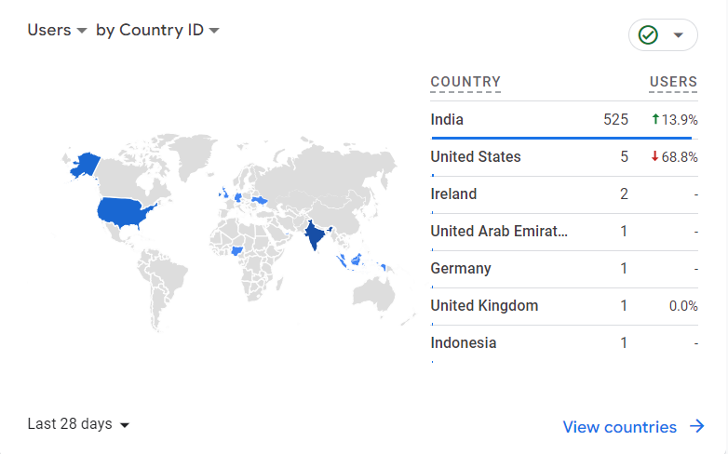

**Figure 5.11 – Whatsapp Bot Form Analytics**

Figure 5.11 shows a commendable surge in Indian user engagement, with 525 counts, simultaneously noting a decline in user interactions from other countries, showcasing Citroën's strategic triumph in the region.

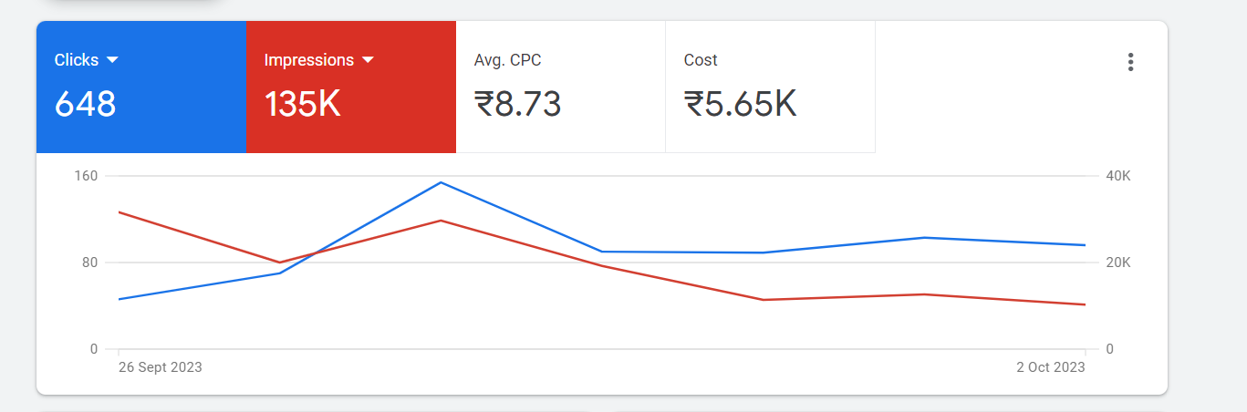  
**Figure 5.12 – Whatsapp Bot Form Analytics**

Figure 5.12 describes, Google Ads campaign achieved notable traction with 648 new clicks from a vast 135k impressions, indicating a robust visibility. With an average CPC of $8.73, Efficiently managed our budget, incurring a total cost of $5.65k."

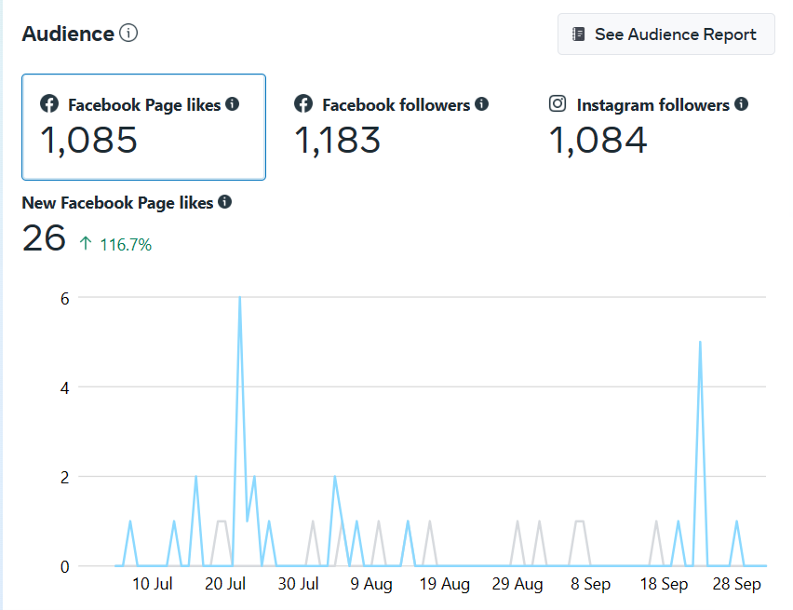

**Figure 5.13 – Whatsapp Bot Form Analytics**

Figure 5.13 shows, A well-maintained scheduling led to impressive visibility with 1,085 audience engagements on Facebook and 1,183 profile visits on Instagram, indicating the effectiveness of our strategic content deployment.

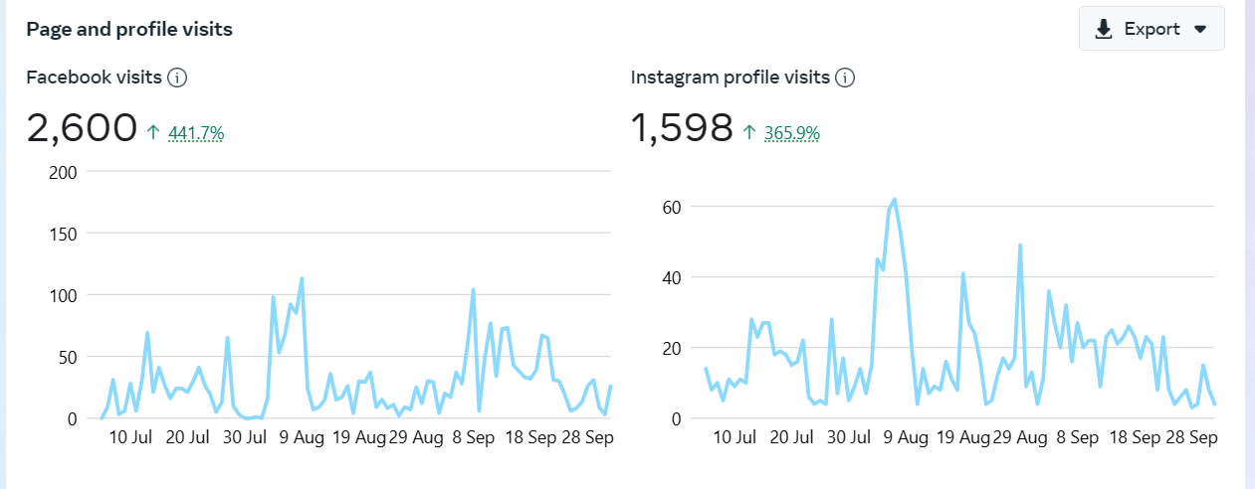

**Figure 5.14 – Whatsapp Bot Form Analytics**

Figure 5.14 shows Citroën page's performance across the Meta suite, Facebook recorded a commendable 2,600 profile visits, outpacing Instagram's 1,598 visits. The consistent scheduling and strategic deployment of creatives have been pivotal in driving these engagement metrics.

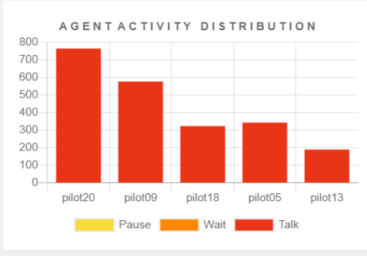

**Figure 5.15 – Tele CMI AgentAnalysis**

Figure 5.15 depicts, Through relentless dedication and efficiency, each agent achieved a remarkable feat of handling over 100 calls with no pauses, showcasing unparalleled agility and professionalism in lead engagement

**CHAPTER VI**

**CONCLUSION**

In conclusion, the key take-aways and learnings are:

The Citroën branding project embarked on an ambitious journey to employ a data-driven engagement strategy, leveraging diverse platforms to enhance the brand's visibility and significantly increase bookings. The confluence of tools like Meta Ads, Google Ads, WATI, Zapier, Metricool, Zoho CRM, Microsoft Clarity, and TeleCMI underpinned the project's successful completion, resulting in the attainment of the set booking targets.  
  
The multifaceted approach employed for Citroën branding was anchored in data-driven insights. Meta Ads and Google Ads served as pivotal platforms, optimizing visibility and ensuring that the brand resonated with the right audience demographics. WATI bolstered real-time customer engagement, ensuring swift communication, while Zapier's automation capabilities fostered seamless cross-platform data integration, enhancing overall efficiency. Tools like Metricool offered invaluable metrics, painting a clear picture of audience engagement and campaign effectiveness, enabling timely strategy adjustments. Simultaneously, Zoho CRM streamlined the customer journey, from initial interaction to booking, ensuring that potential leads were nurtured and converted. The visual insights from Microsoft Clarity, including heatmaps and session replays, were instrumental in refining the user experience on the Citroën website. TeleCMI's cloud telephony solutions ensure a consistent brand message and enhanced customer support, solidifying the brand's rapport with its audience.  
  
The successful completion of this project underscores the significance of a multi-pronged, data-driven strategy in today's digitized marketplace. Citroën's triumph in both branding and conversion metrics serves as a testament to the potential of using integrated tools with a clear, data-backed vision. As the digital landscape continues to evolve, the learnings from this endeavor will remain pivotal for future campaigns and initiatives, setting a benchmark for excellence and strategic depth.

**6.2 Recommendations for Future Enhancements**

* **Instagram Integration**: Leveraging Instagram can open doors to a more varied and younger demographic. The platform's visual appeal aligns well with Citroen's branding.
* **User-generated content**: Encourage satisfied customers to share their experiences on platforms, providing organic branding and building trust.
* **Expand Reach**: Consider exploring other emerging platforms or technologies to stay ahead in the digital race and engage with a broader audience segment.
* **Continuous Training**: Tools like WATI and TeleCMI are only as good as the teams using them. Continuous training ensures that customer queries are addressed effectively, leading to better conversion rates.
* **User Experience Refinement**: Based on user interactions and feedback via Tele CMI and WATI, focus on refining the digital touchpoints to make them more intuitive and user-friendly

**BIBILIOGRAPHY/ANNEXURES**

**WEB REFERENCE**

[1]<https://learn.nestify.io/pagespeed/?utm_campaign=MINT+LP+Conversions&utm_source=fb&utm_medium=cpc&utm_content=Ad+1&utm_term=%5BPS%5D+Lookalike+-+India&ad_id=23861472589840642&fbclid=PAAaY_JJkqnwtgoIo5JjK3UMELcTlBtaJsw9EqORFdXuaQ3gtAloN7JK2xDbI_aem_AVApPkbrfCOGyJrPAcSAVtLHYiWavx_y_a3FGVdmKWPMWwXkTzOFgJehlEcj8Do3BSRQ4owf2H3cpVzlbVA_E4jj#lp-pom-text-154>

[2] <https://www.wati.io/no-code-chatbot/>

[3] <https://knowledge.hubspot.com/ads/create-facebook-and-linkedin-lead-ads-in-hubspot>

[4] <https://metricool.com/tips-for-linkedin/>

[5] <https://www.zoho.com/crm/resources/tips/>

**JOURNALS**

[1]<https://www.researchgate.net/publication/312639584_An_Analysis_on_the_Use_of_Google_AdWords_to_Increase_E-Commerce_Sales>

[2] <https://neilpatel.com/blog/facebook-business-suite/>